

TABLE OF CONTENTS
ELECTRONIC FILING

I. Electronic Docket
1. Add Citation (input all citations to build docket, including all municipal ordinance citations)
- Edit Citation (correct citation entries in docket program)
- Create Docket (print docket for court)

II. Electronic Abstract
- Add Convictions (to send abstract convictions to DPS)
- Conviction Record Reports (run conviction record search’s on local records and system wide records

III. Electronic Forms
1. Action Forms (court order suspensions/withdrawals)
2. Facsimile (to amend/correct/dismiss abstract records currently on driving records)
- Suspension/Revocation Removal Form (to remove suspension that was done in error ***ONLY****)
4. Suspension/Revocation Form (for under 21 suspension request by Judge for alcohol/drug related offenses)

IV. Processed Citation Report (run report for number of convictions to report to OSBI & Cleet)

V. Financial Reports/Receipts (print receipts and run financial reports)

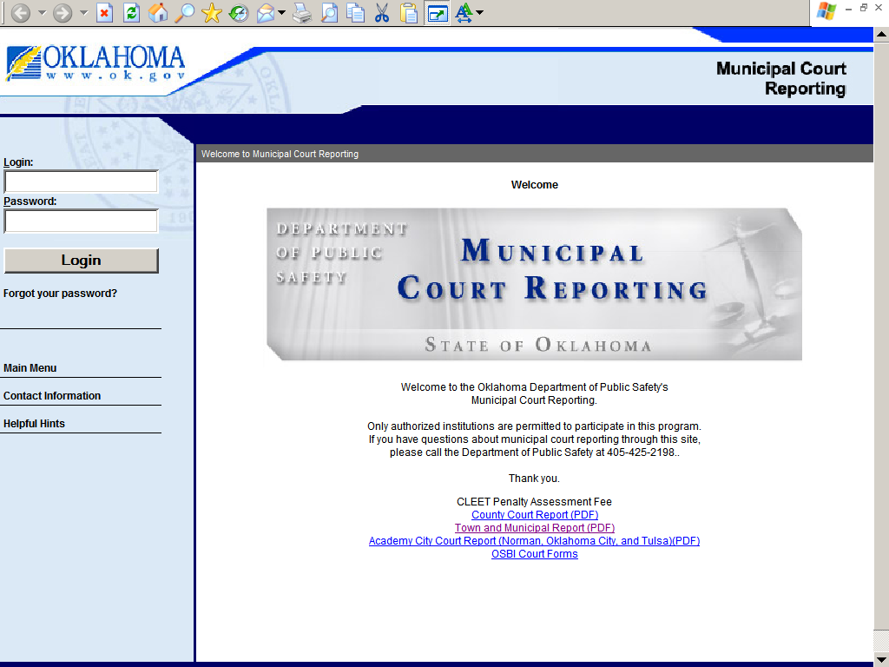
Instructions:
1. Internet connection

2. Municipal Court Reporting (www.ok.gov/dps/courts)
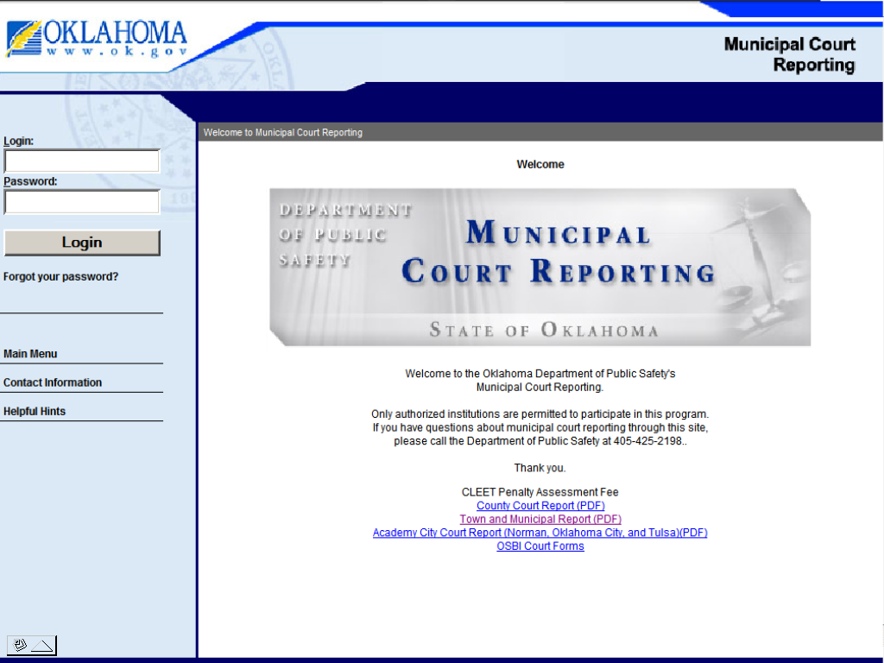

3. Hotlinks – in blue at bottom of page to OSBI and CLEET penalty assessment forms (can be filled out on the computer, but must be printed and mailed in with your payment).

4. Log in -(user ID – your complete e-mail address, and password you created)
Left margin is the log in and below that is a link if you forget your password. Also, on the left margin the main menu, contact info (court liaison information), and helpful hints for a online manual and offense codes.

5. Main Menu Page - (select) Municipal Court Reporting
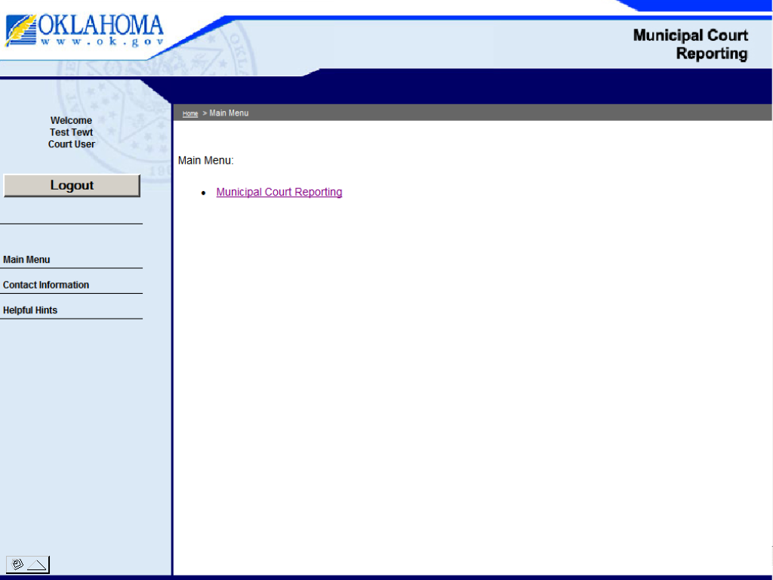

6. Sub Menu Page - (select one)
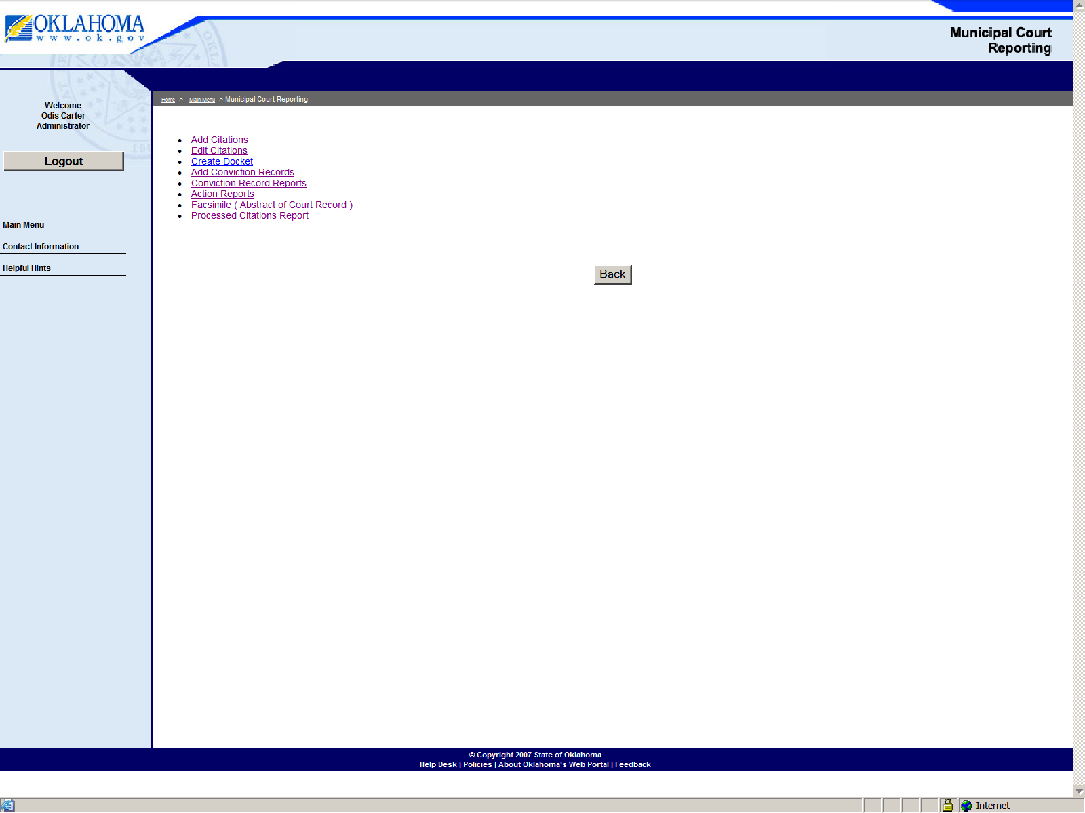

7. Add Citations – (to build your docket) - enter all abstracts for court (traffic - with DPS Codes and non-traffic with a MC0 code Municipal Ordinance). Using the abstract from the officer, fill the information in the appropriate fields.

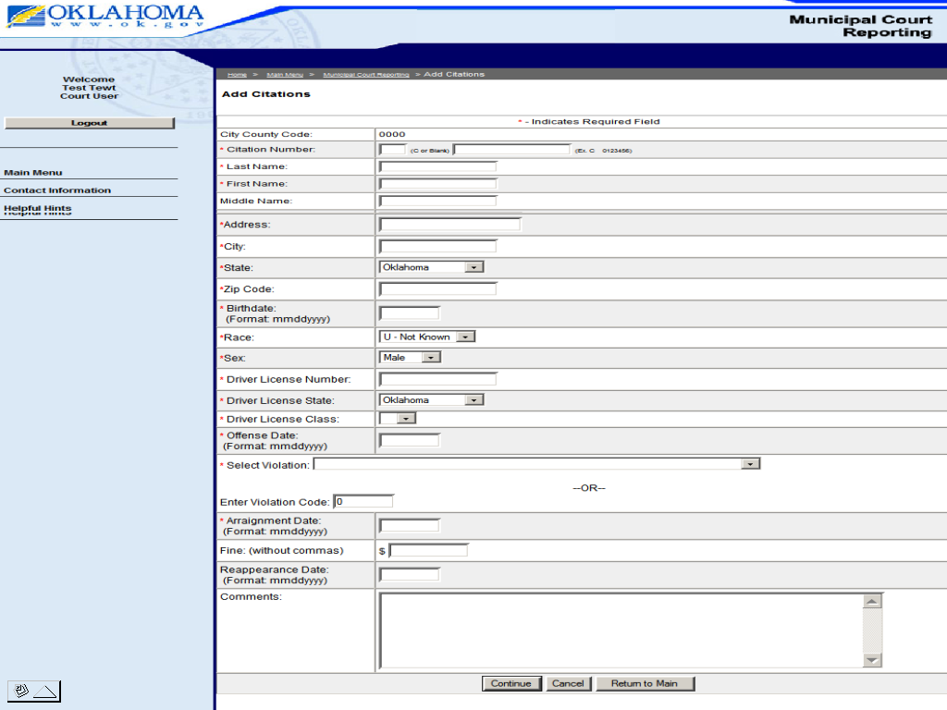

After all fields are completed push the continue button!

8. Automatic edits – your entry will go through an edit process and let you know if there are any mistakes that need corrected. Note: The edits only check for the correct type of information for that field. Example below indicated by red type at the top of the screen. Make corrections on your entry and push the “continue button” to go through the edit process again.

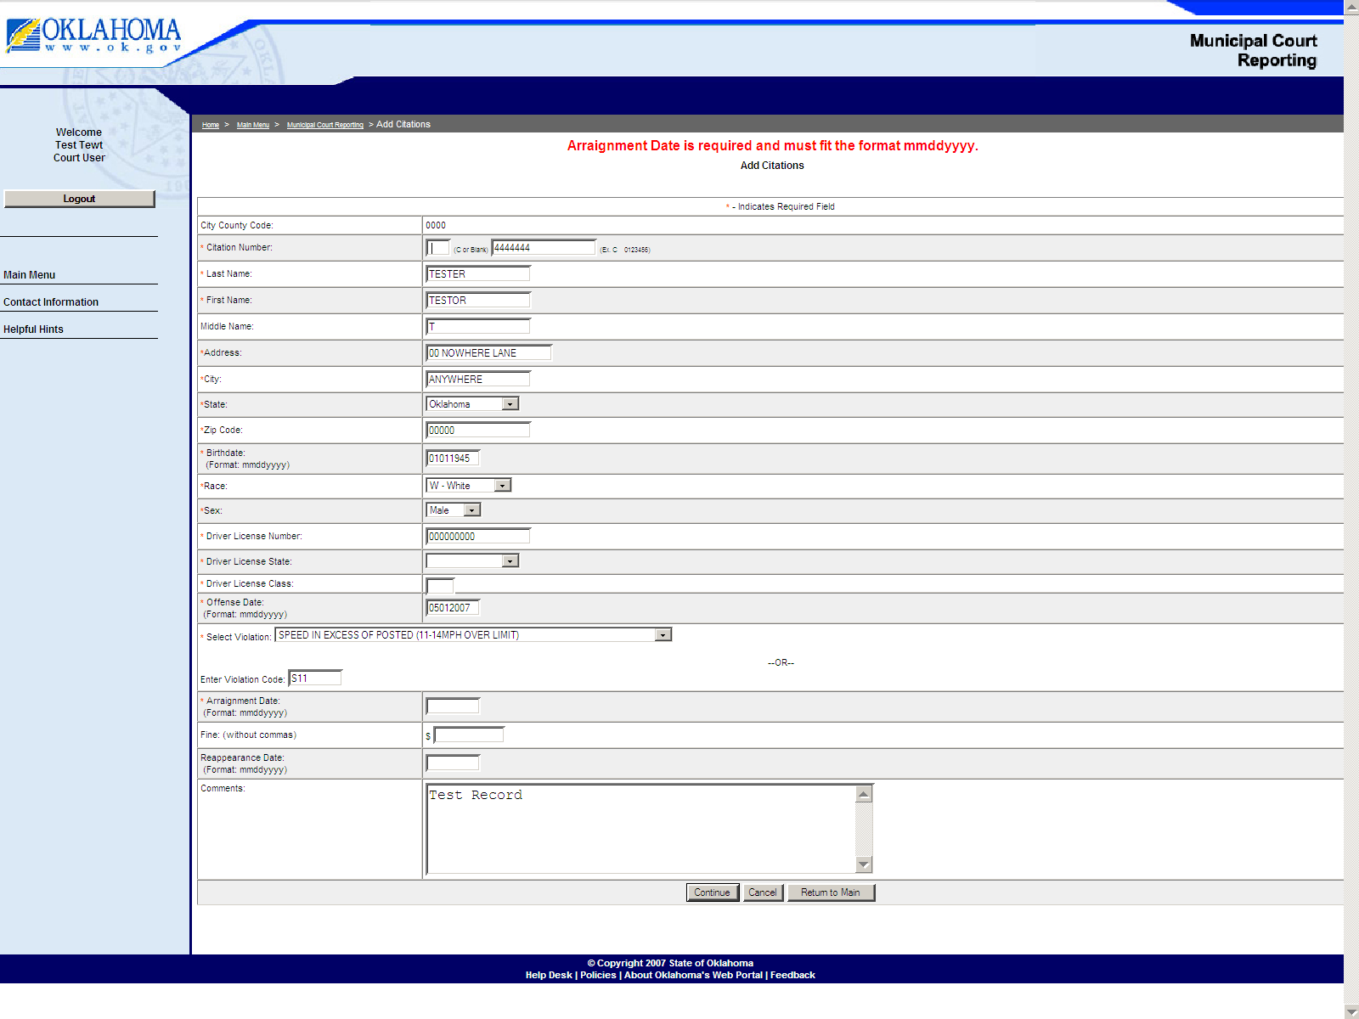

9.Verify Citation page – If there are no corrections to be made the following verification page will show you the information you just entered. This is to allow you to check the information once more to ensure that the correct information for that abstract has been entered before the abstract is entered into your record.

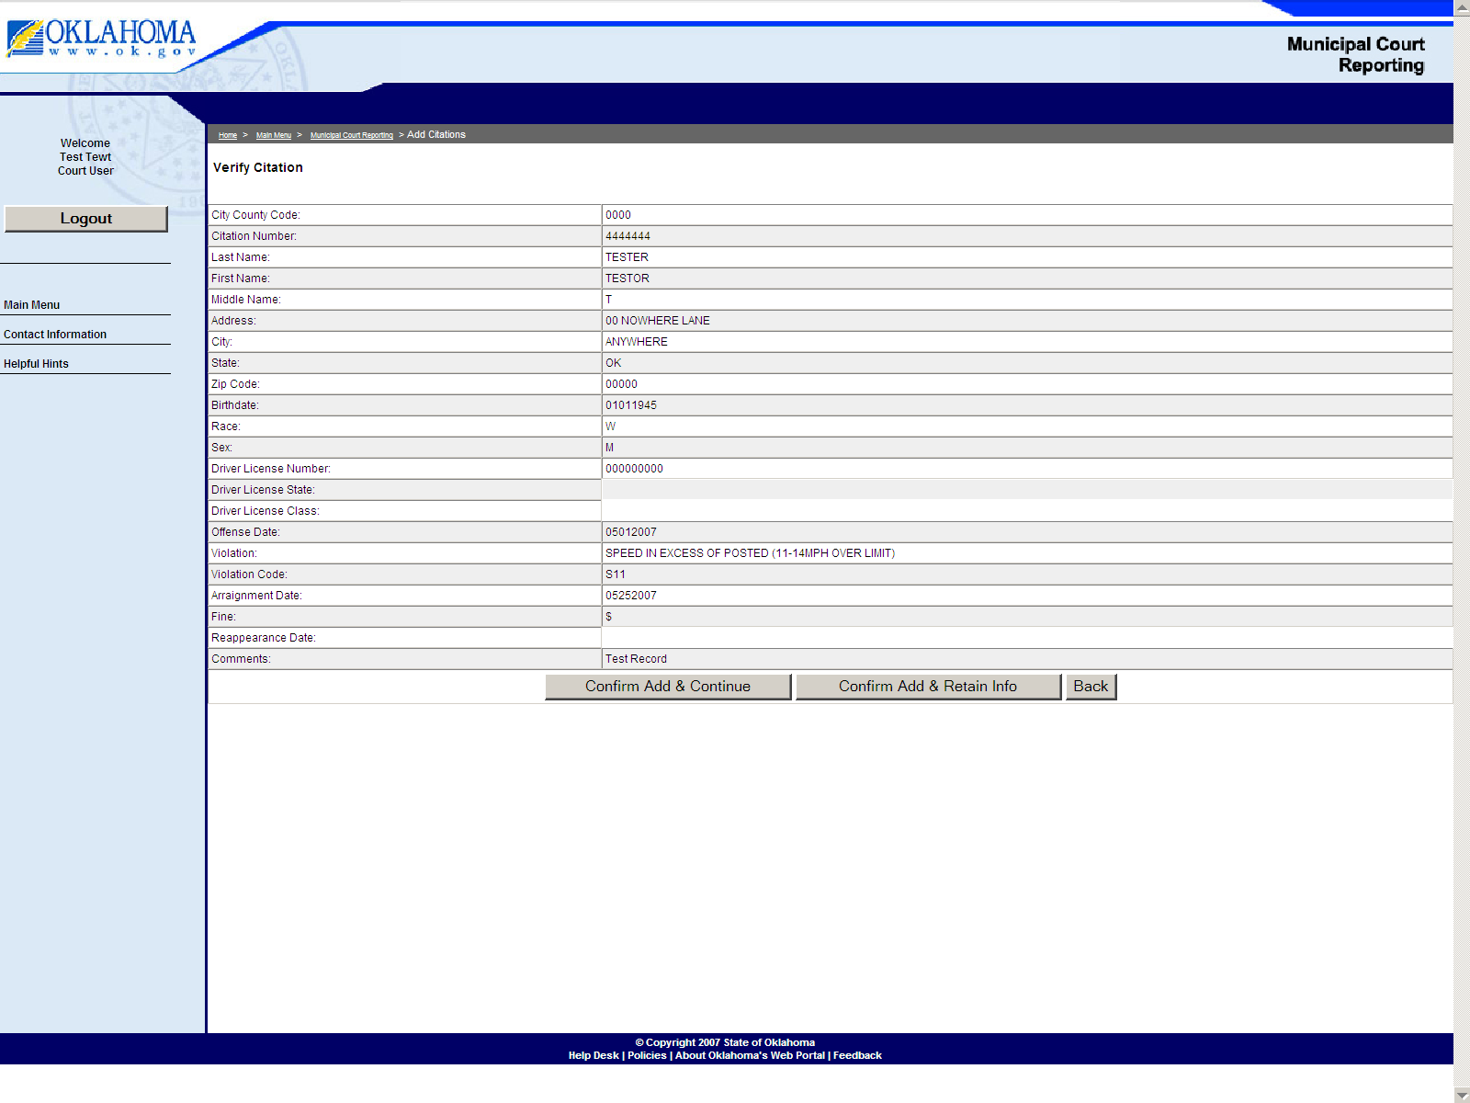
If all entries are correct, push the confirm add & continue button to add the citation into your record for the docket and open up another blank add citation page for other entries or push the confirm add & retain info button to add the citation into your record for the docket and to open another add citation page with the personal information retained from the previous entry for multiple citations on the same individual.

10. Edit Citation page – This page is where you can recall a citation that has already been entered into your records for the docket. You may recall the by citation number and make any changes to the record for payment purposes (processed), dismissed, deferment or for arraignment date changes etc. Enter the citation number and push the submit button to recall the record and to edit the file. Example below!

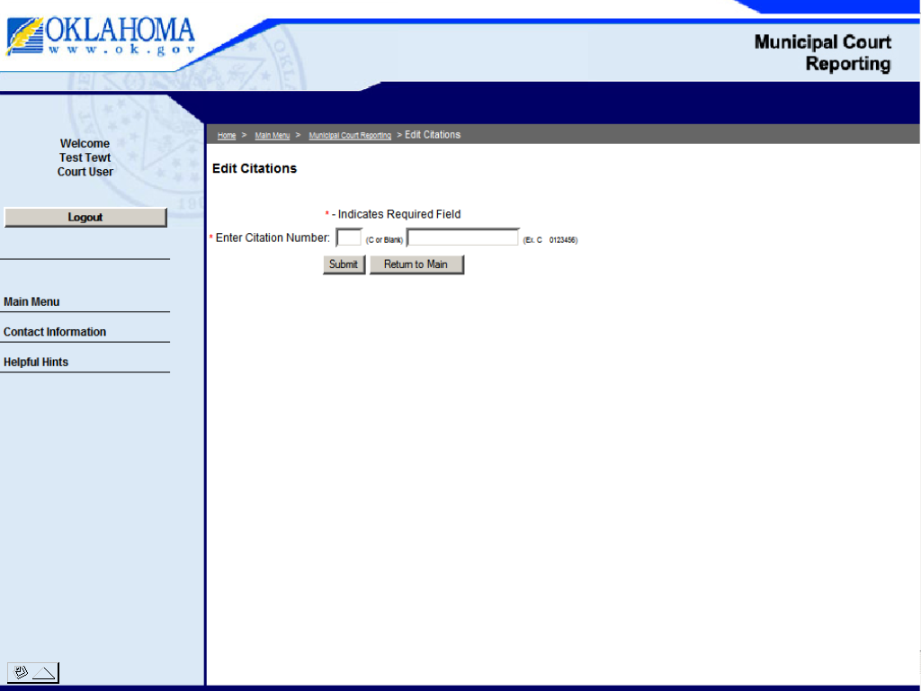

The previously entered citation will appear for any corrections to be made.

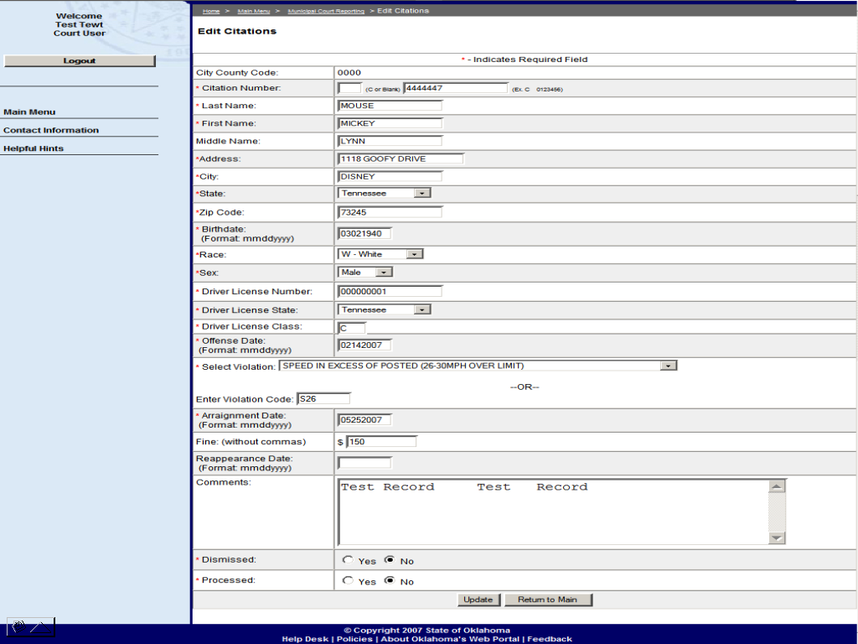

After corrections are made, push the update button to add the citation into your record for the docket.

You will receive a page indicating Confirmation of edit to citation as shown on next page.

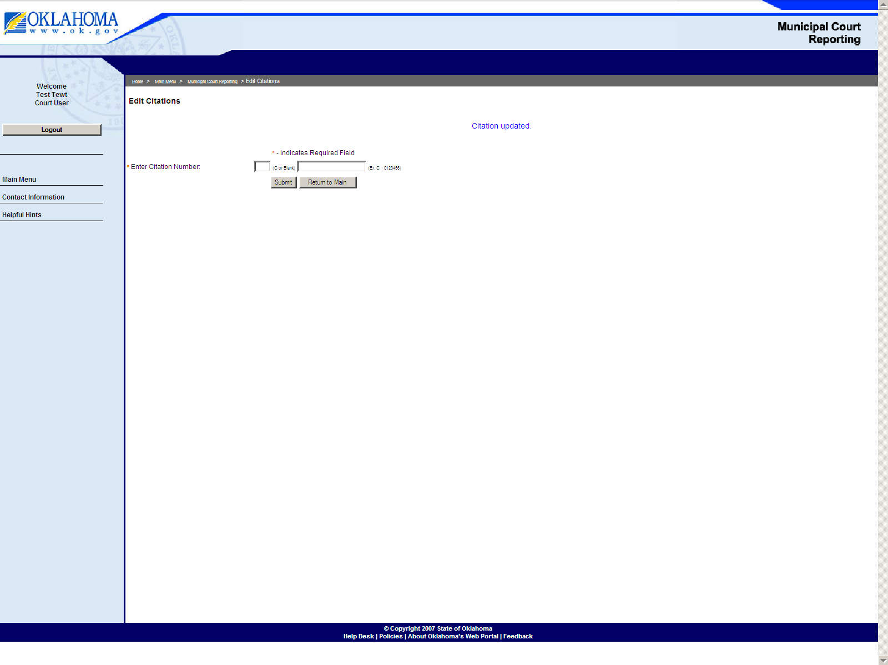

11.Create Docket – To create and print out your docket for court.
(enter arraignment date and press create button)
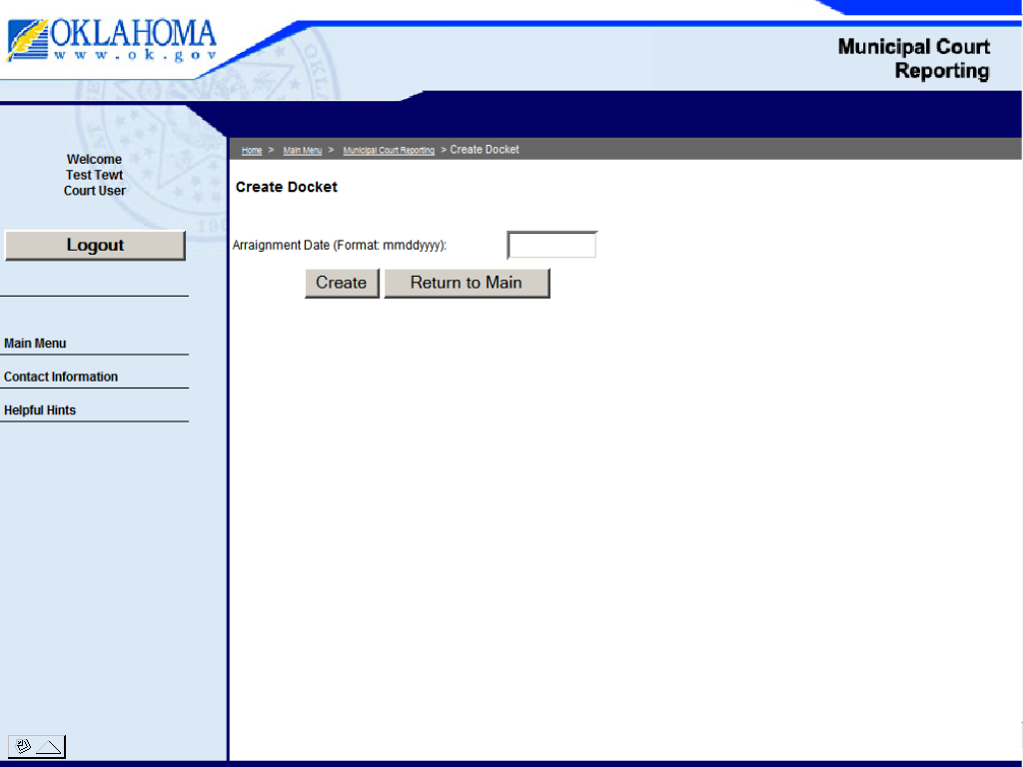

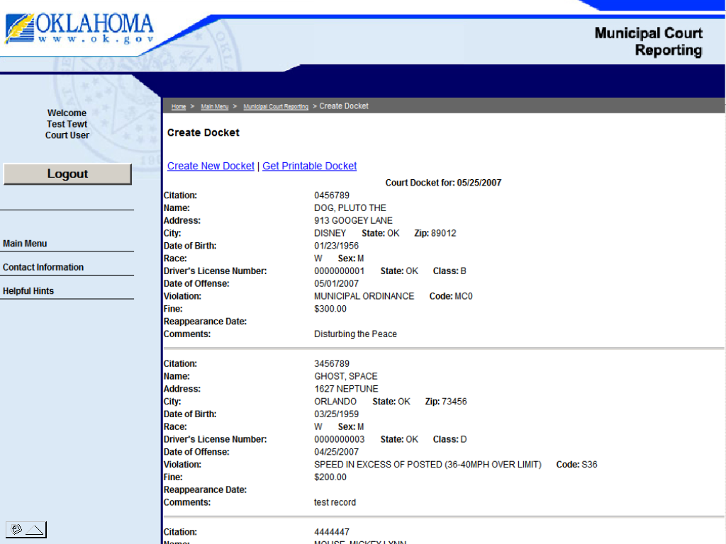
(press get printable docket blue link)

Electronic Abstract Instructions -
Entry with or without using docket page!

Add conviction records: enter abstract for electronic filing- convictions only.

If Utilizing the Docket Page: enter the citation number and all information from the docket page will be automatically filled in by the program onto the abstract page. You will need to fill in the court conviction information at the bottom of the abstract page.

Entering Abstract convictions only without utilizing Docket page:

*Complete all required fields *:

Special Instructions
Name: last name field only - use a dash or space between multiple last names.
Middle name field: if a suffix, place after the middle initial/name with a space.
Address: ½ numbers in address, type the word half -555 1/2 as 555 half.
Driver license number: if no DL, type “NONE”.
– Oklahoma set up numbers can be entered as a DL numbers ex. 990------.
- Do not use ID numbers (999-----) as DL numbers.
DL Class: is a (1) character space only, if out of state and is more than one character – use the first letter of the class.
Vehicle information: only required for insurance violations.
Case numbers: numerical field only -no dash or slash marks.
Conviction date: this date has to be after the offense date.
Comments: for your use only, info not sent to DPS.

**Please check your entries before submitting to DPS for
any incorrect information! **

****** Most common errors are spelling and dates! **********

12. Add Abstract page - (Convictions only) – to be sent to DPS.

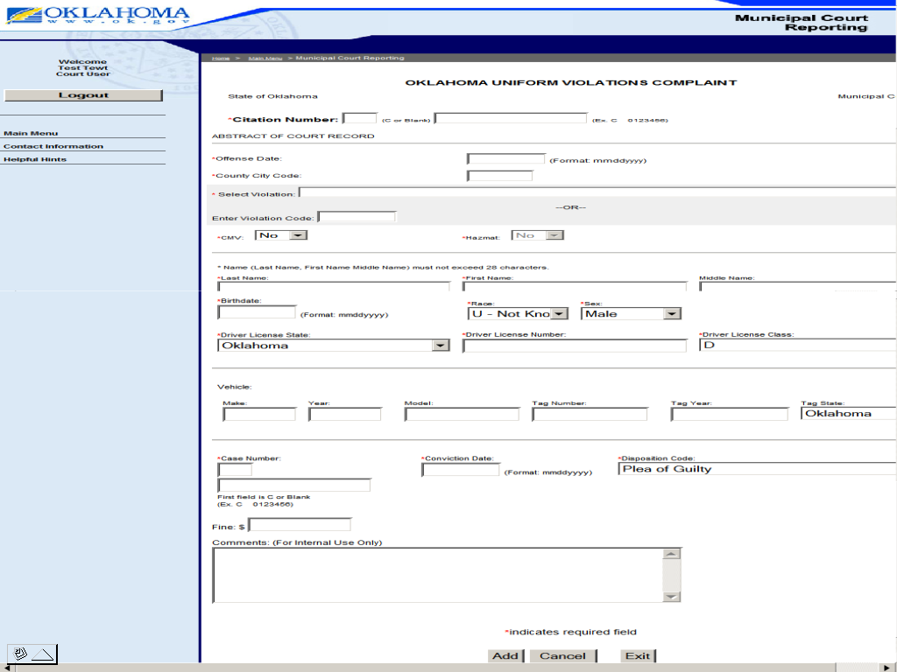

After completing all fields, push the “add” button.

13. Automatic edit check – your entry will go through an edit process and let you know if there are any mistakes that need corrected. The abstract you are entering is below the red edits, just scroll down to make corrections as indicated by program. The edits only check for the correct type of information for that field, not that the information is correct to that abstract!

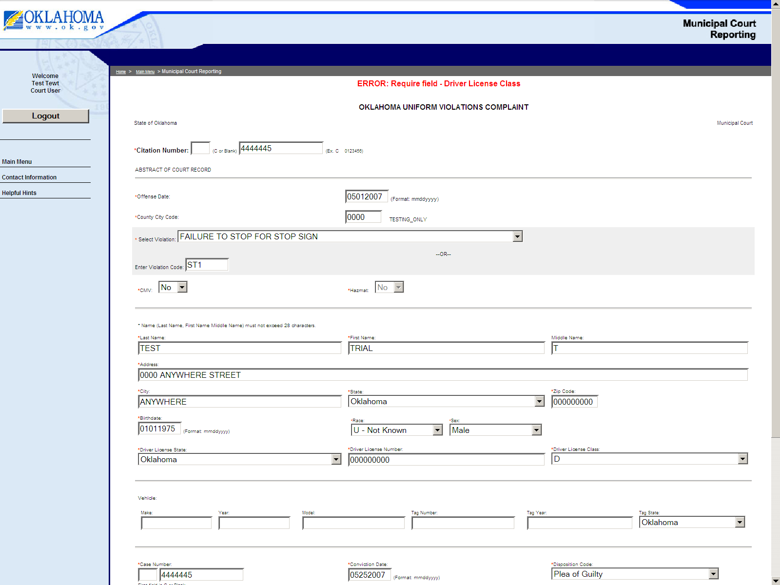

After all is completed, push the “add” button again for the self edits check. If no errors a verification page will appear allowing you to check the abstract entry for the correct information for that abstract.

14. Verification page - of abstract information to be sent to DPS.

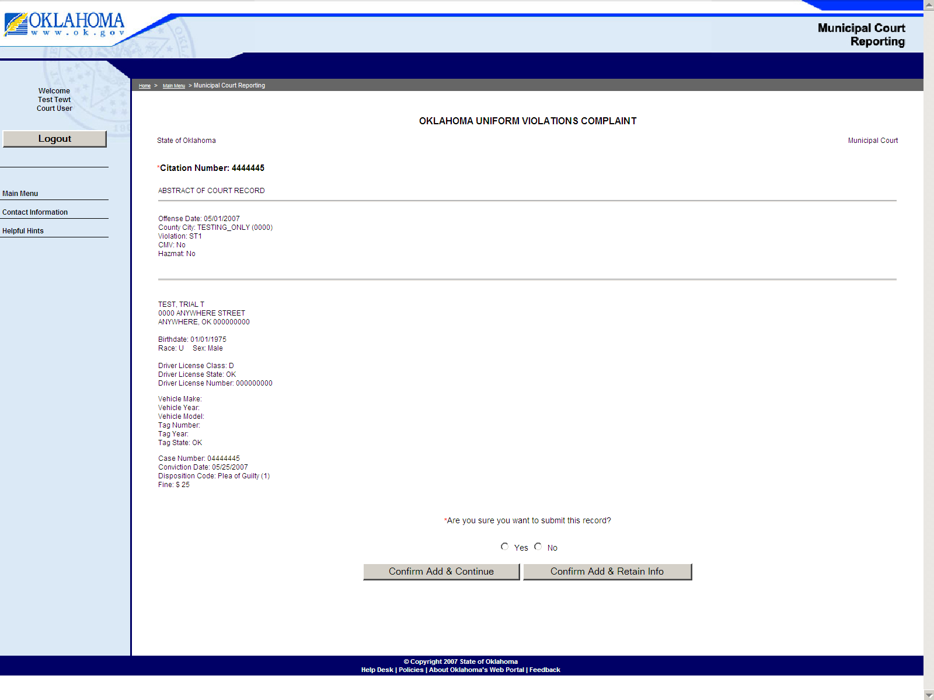
After all fields have been verified by you, answer the two tier questions. Push “Yes” or “No”, (NO and confirm add to go back to correct any incorrect information), then either “confirm add and continue” to send the abstract and to bring up another blank abstract entry form or “confirm add and retain info” to send the abstract and retain the personal and vehicle information for multiple abstracts on one person. Example below!

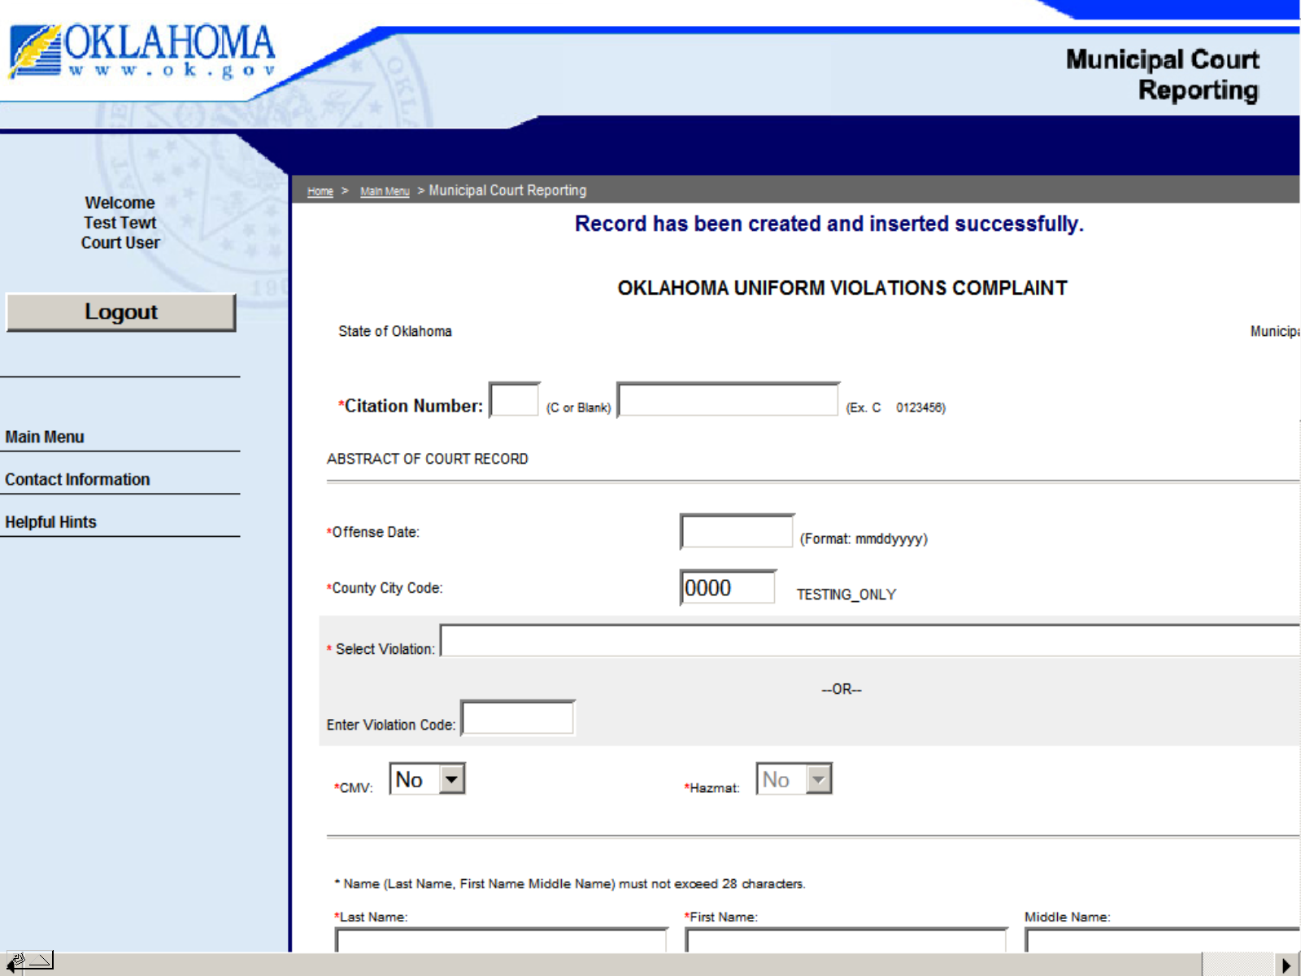

15. Conviction Records Reports page –
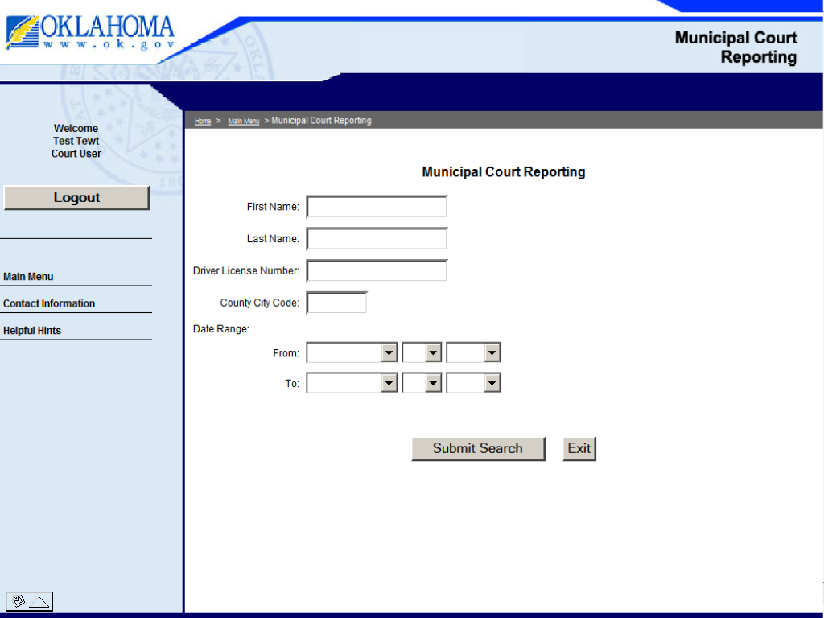

Searches can be conducted by entering the First and/or Last Name or an OLN, but not both types of information! This will search records system wide for entries by your court and all other court users. To search your records, add your city/county code along with the above information and push the submit button. Searches may be conducted for record management purposes by using the date range fields along with your County/City code.

The following page is an example of the record search!

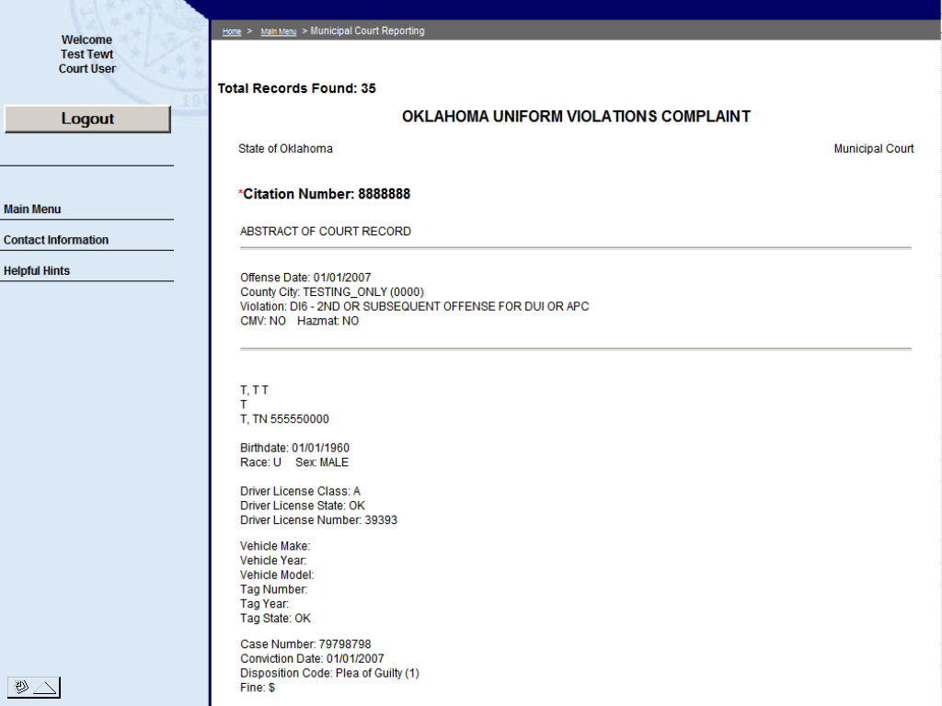
16. Action Reports - This page is for suspension request/withdrawal orders. If you are utilizing the docket page or the add conviction page, the information will populate from the citation number entered. If previous information has not been entered on either the docket or add conviction page, you enter the citation number and a message will tell you that that citation has not been found and to complete the form for submission to DPS.
- Enter citation number
- Select the type of action requested
- Note: Failure to Satisfy Sentence is for Under 18, as is Satisfied Court Sentence. (Sentence not satisfied field – type what the sentence was by the court that was not satisfied).
- Enter date (required if you are submitting a withdrawal order)
(Date Court ordered withdrawal)
- Press continue button
- Municipal Ordinance code – MC0, when used will need an actual description typed in “Description of Violation” field. DO NOT use numerical municipal codes as description.

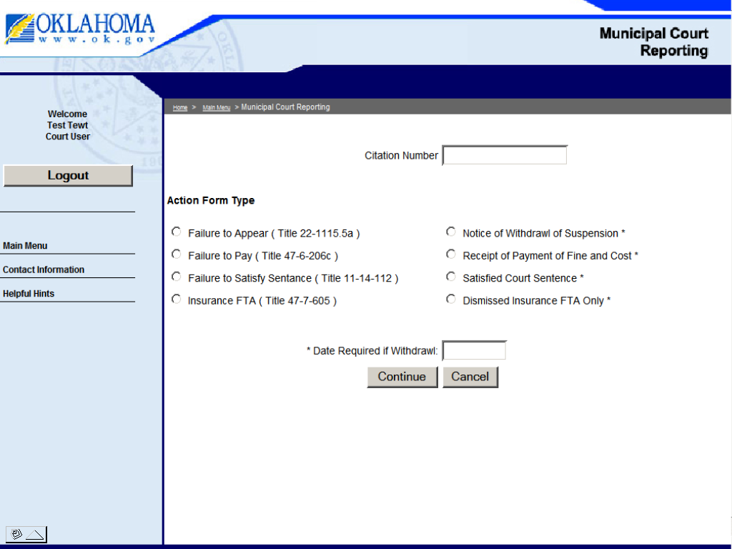

The following is an example of the action form-

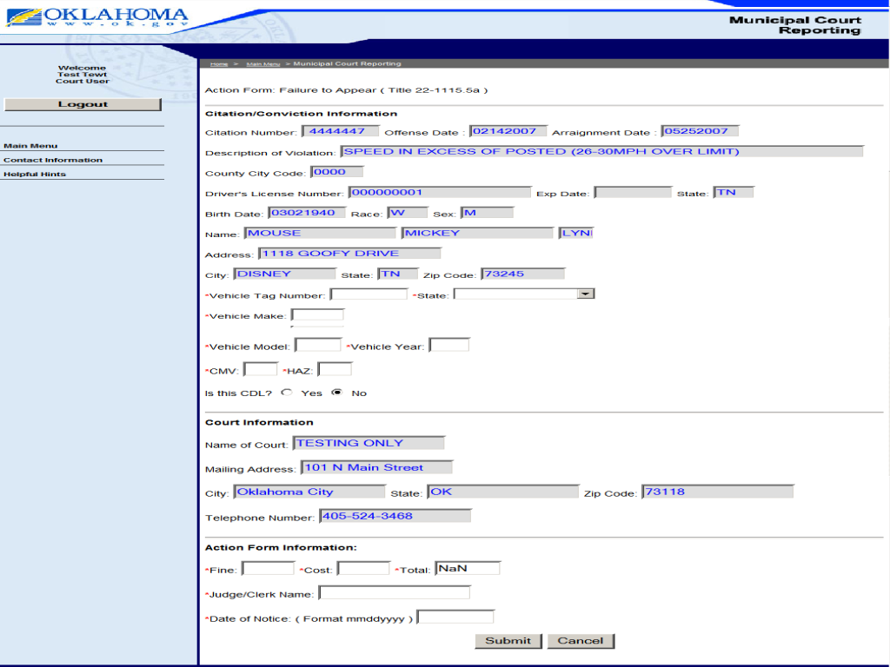

17. Facsimile Form: - Enter citation number and fill out the form.
THE FACSIMILE FORM SHOULD BE USED FOR THE FOLLOWING:
1. WHEN DEFENDANT IS “BOOKED” OR “JAILED” AND AN ABSTRACT IS NOT ISSUED.
2. ORIGINAL VIOLATION HAS BEEN SENT TO DPS & COURT IS AMENDING THE VIOLATION.
3. ORIGINAL DISPOSITION (GUILTY, NOLO, BOND FORFEITURE) HAS BEEN SENT TO DPS - DISPOSITION IS AMENDED (DEFERRED, DISMISSED, EXPUNGED)
* THIS FORM WILL NOT RELEASE A SUSPENSION!
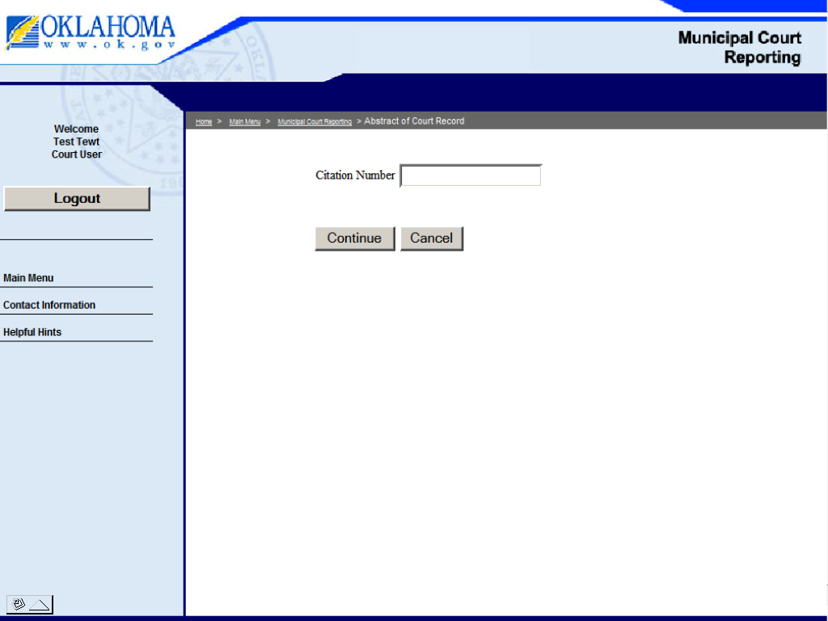
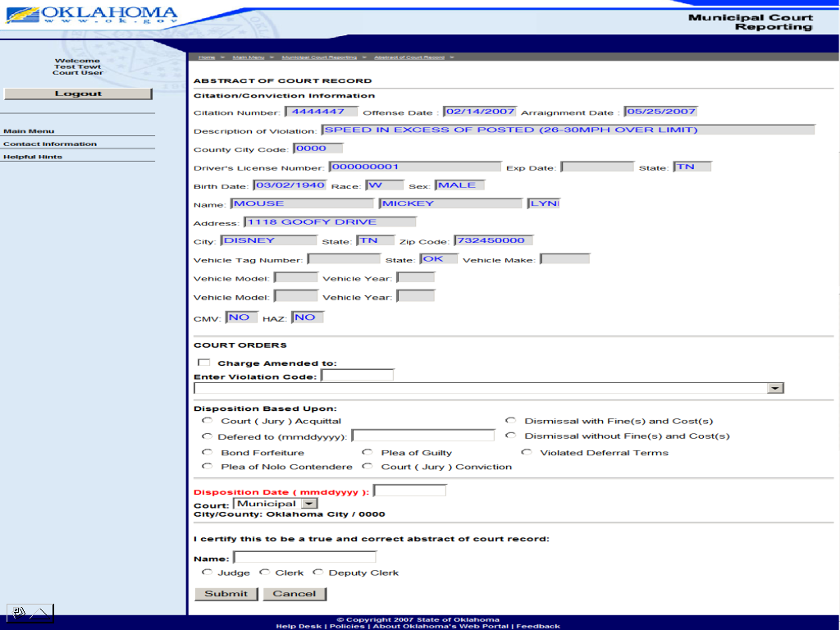
** Check the information, type your name and select your title and press the submit
button.

**If no error’s, the program will state that the form has been accepted
and gives you the choice of printing a copy for your records! **

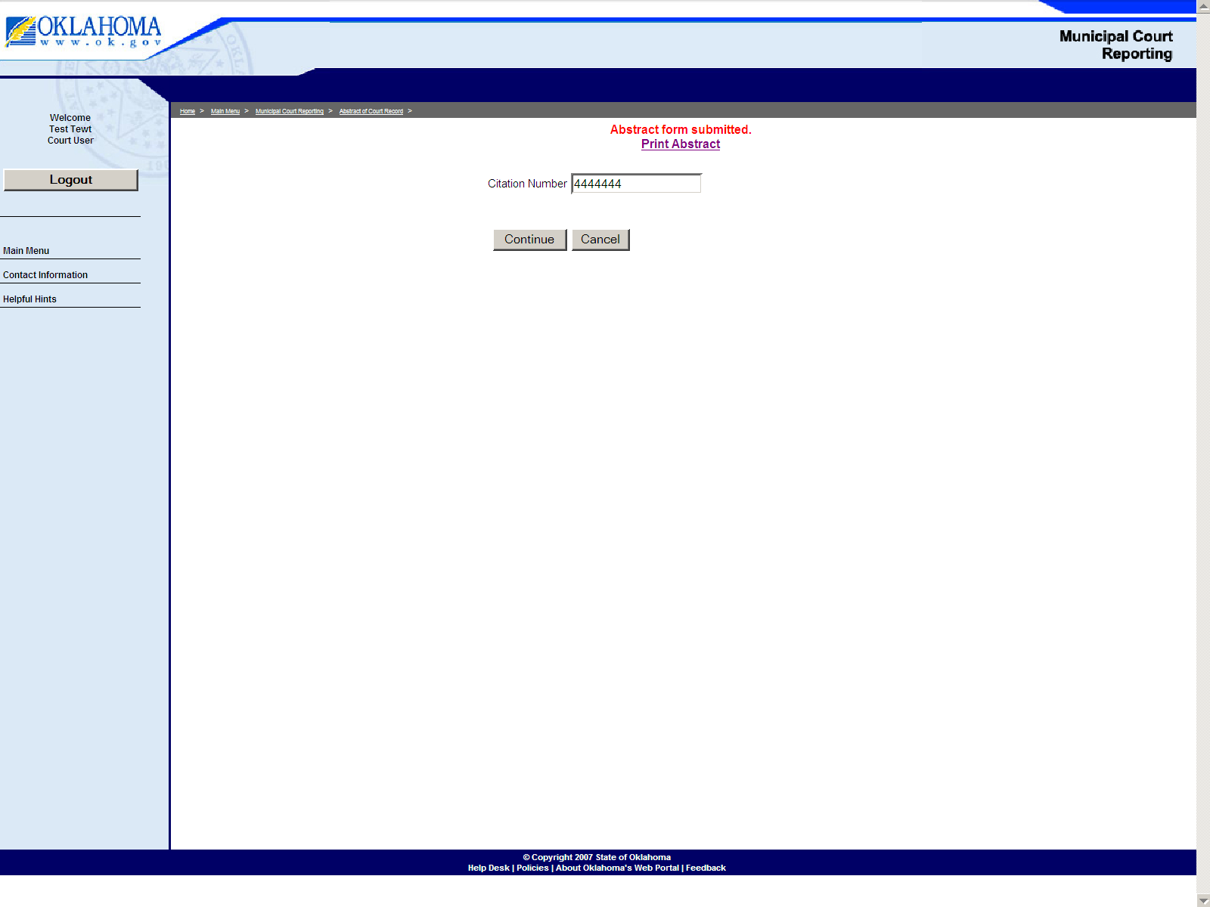 Processed Citations

- Processed Citations Report (run report to get number of
Convictions to report to OSBI & CLEET)

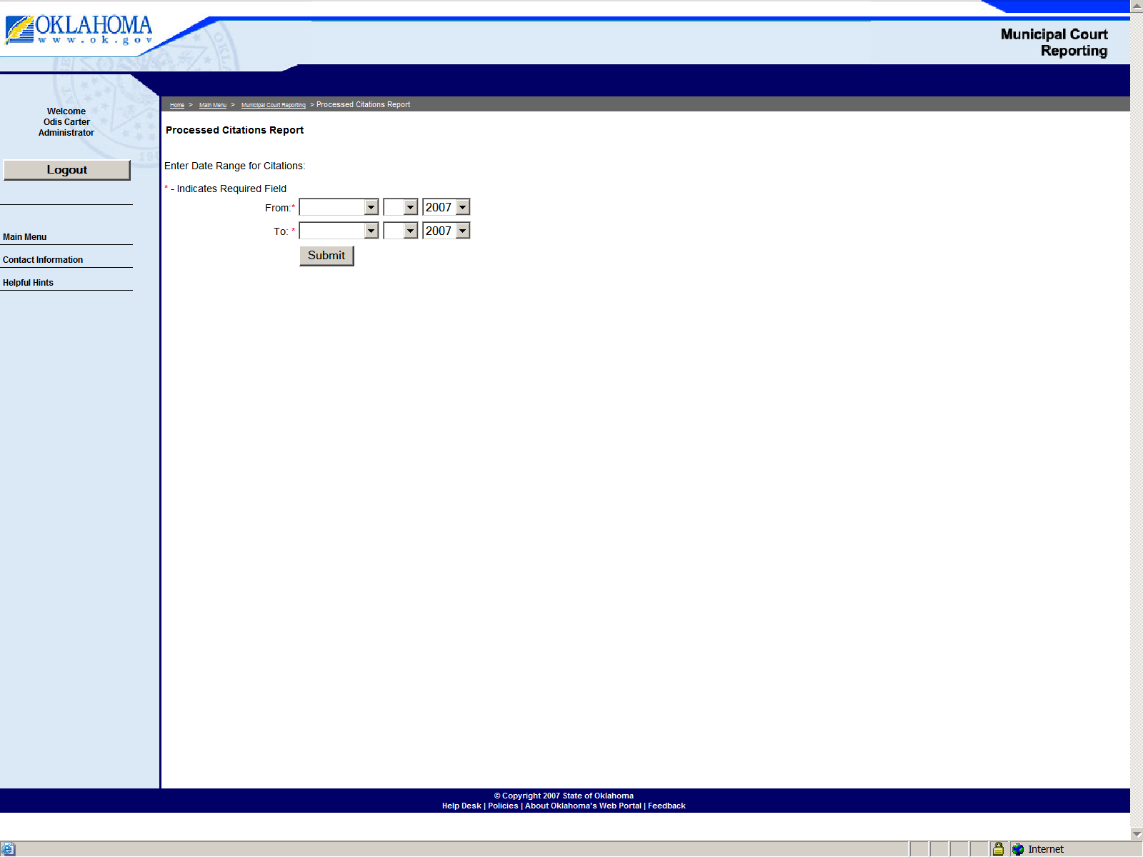

- Financial Receipts and Reports (run report for financial
Receipts from court and printable receipts of payments made to
The court.)

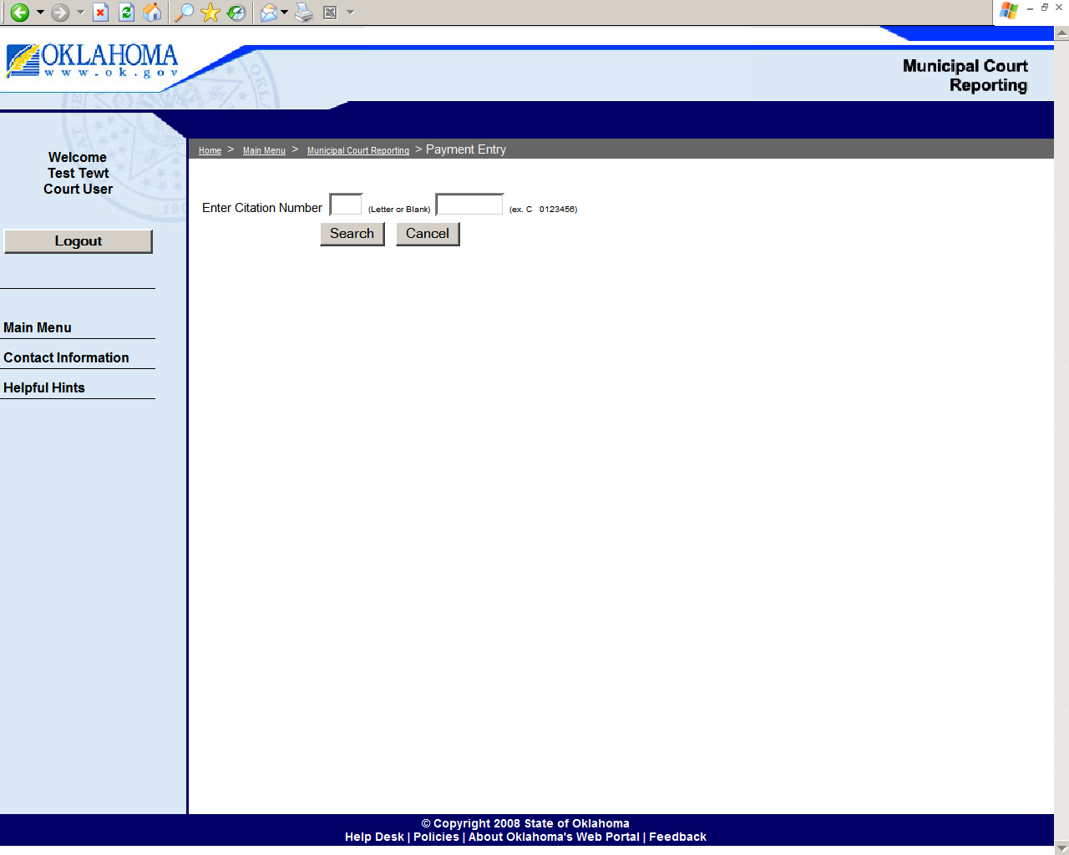

Entry page for receipts, just fill in the amounts due and save. Next screen
Click save again if no edit to amount, then enter amount paid, date of payment and
type of payment then click on save and then receipt button to be printed.

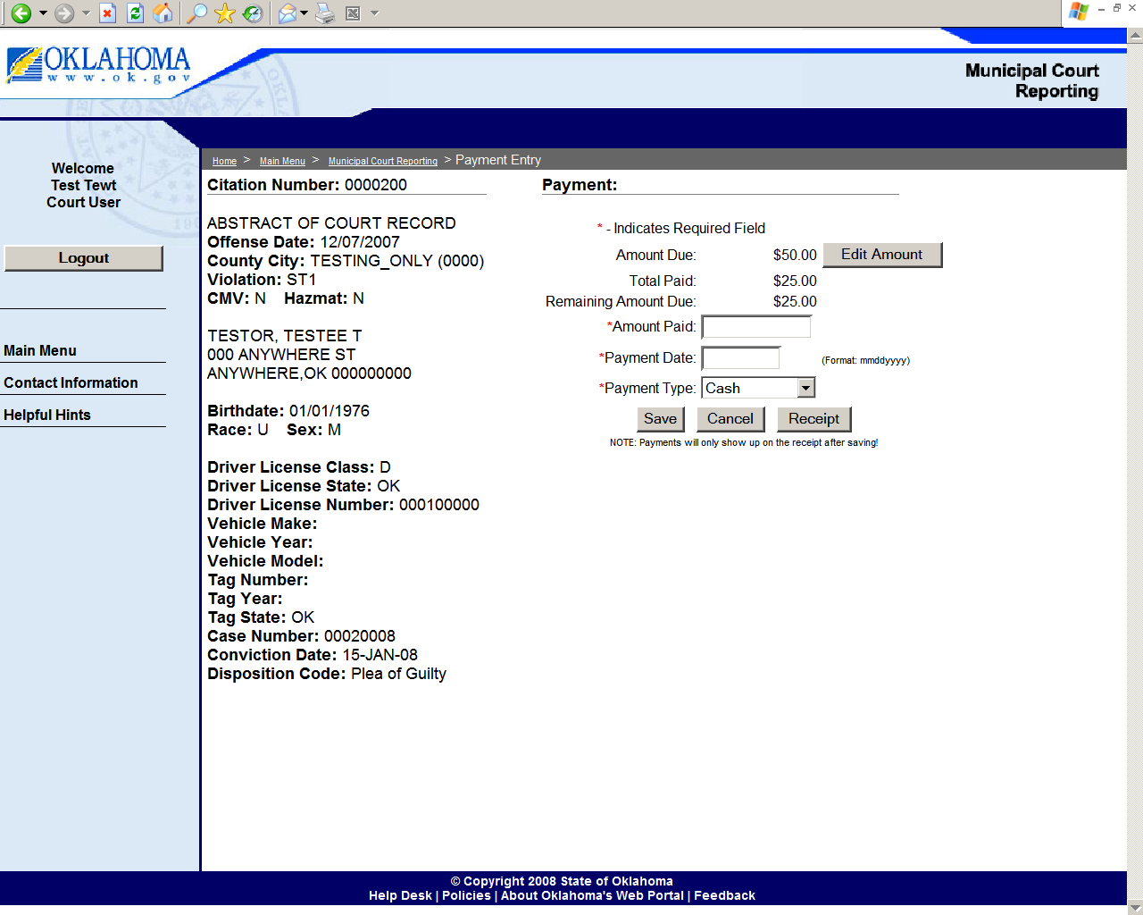
Below is an example of a receipt. The payment date and amount paid area
will show payment schedules in the event of multiple payments!

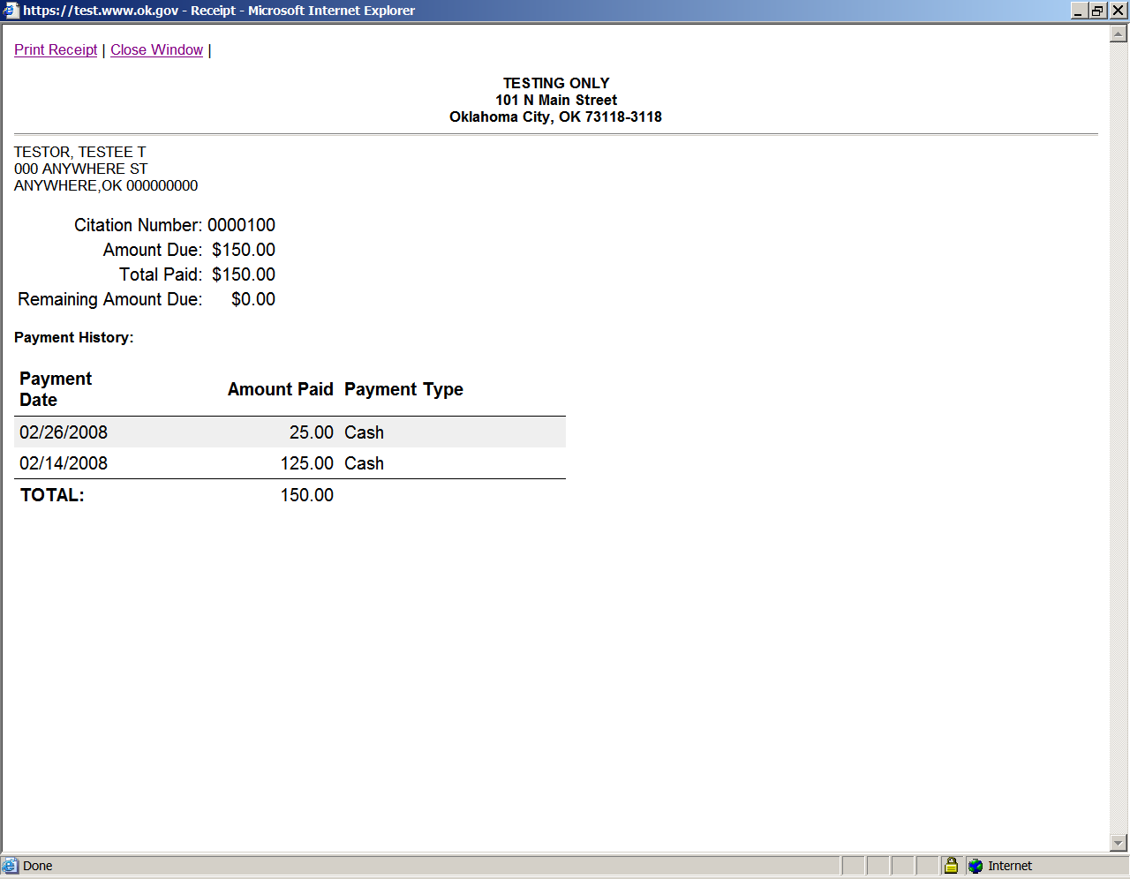

Below is an example of the financial reports, you may run a report showing
All citations, citations that you have received payments on, and citations that
Are still outstanding.

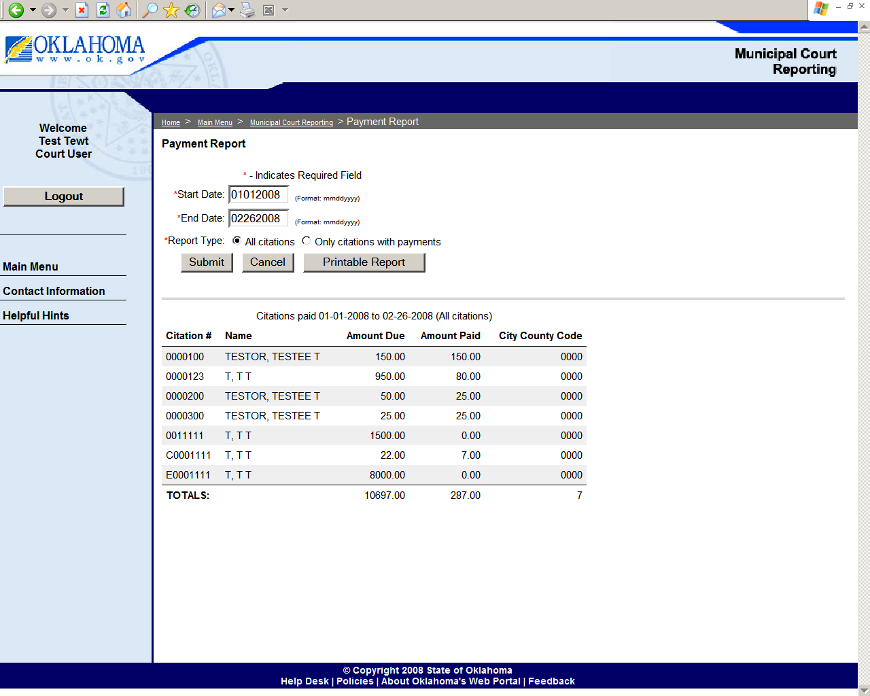
- Suspension/Revocation Removal Form (to removal a
Suspension order that was sent in error ***ONLY***)
Coming Soon!

- Suspension Request Form – (Judge’s request to suspend Under
21 for alcohol/drug charges for defined time periods)
Coming Soon!

RECORDS MANAGEMENT DIVISION
PO BOX 11415, OKLAHOMA CITY, OKLAHOMA 73136

VIRGIL BONHAM
DIRECTOR
(405) 425-2047 – Office
Virgil.Bonham@dps.ok.gov
OCRSHelp@dps.ok.gov – Email any questions or concerns regarding DPS OCRS

GINA SMITH
ASSISTANT DIRECTOR
(405) 425-2198 – Office
Gina.Smith@dps.ok.gov
OCRSHelp@dps.ok.gov – Email any questions or concerns regarding DPS OCRS

DOCUMENTS TO BE SENT TO THIS DIVISION:
ABSTRACTS
AMENDMENTS OF ABSTRACTS/CORRECTIONS
COLLISION REPORTS (IF THE POLICE DEPARTMENT DOES NOT)

COURT LIAISON
MARCIA UNSELL
ADMINISTRATIVE ASSISTANT
(405) 425-2194 – Office
(405) 419-2020 - Fax
Marcia.Unsell@dps.ok.gov
OCRSHelp@dps.ok.gov – Email any questions or concerns regarding DPS OCRS

DRIVER COMPLIANCE DIVISION
PO BOX 11100, OKLAHOMA CITY, OKLAHOMA 73136-0100

DOCUMENTS TO BE SENT TO THIS DIVISION:
FAILURE TO APPEAR ON COMPULSORY INSURANCE VIOLATION
NOTICE TO WITHDRAW SUSPENSION (INSURANCE VIOLATION)
FAILURE TO APPEAR, -NOTICE TO WITHDRAW SUSPENSION.

NON-PAYMENT OF FINES AND COST - NOTICE OF PAYMENT OF FINES AND COST, -FAILURE TO SATISFY SENTENCE OF MUNICIPAL, COURT-NOTICE OF COMPLIANCE FROM MUNICIPAL COURT

RANDY BALTHAZAR
(405) 425-2190 - Office
(405) 425-2321 – Fax
Randy.Balthazar@dps.ok.gov

PHONE NUMBERS FOR COURT CLERKS ONLY!!! NOT FOR PUBLIC USE.

