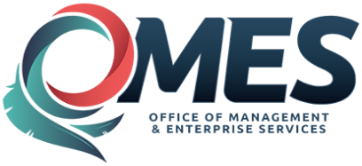 | State of Oklahoma | Statewide Contract  Addendum

This addendum is added to and is to be considered part of the subject contract.

Statewide Contract #: | SW1053Z
PeopleSoft Contract ID: | 4756
Contract Title: | Public Safety Communications Equipment
Contract Issuance Date: | 04/06/2017
Contract Supplier: | Zetron
Addendum # | 1
Addendum Date: | 06/29/2017
OMES Point of Contact:
Contracting Officer: | Marc Brown
Phone Number: | 405-521-3381
E-mail address: | Marc.brown@omes.ok.gov
Addendum Information:
Addendum #1 issued for contract renewal for Zetron.
Contract Period: 07/02/2017—07/01/2018
Agreement Period: 04/06/2017—07/01/2020

