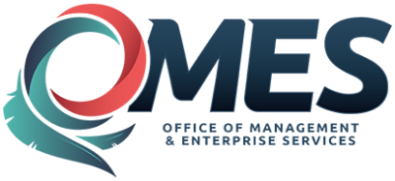 |  | Statewide Contract  Addendum

This addendum is added to and is to be considered part of the subject contract.

Statewide Contract #: | SW1010
PeopleSoft Contract ID: | 3245
Contract Title: | Microsoft Reseller
Contract Issuance Date: | 07/26/2016
Contract Supplier: | SHI
Addendum # | 4
Addendum Date: | 03/28/2017
OMES Point of Contact:
Contracting Officer: | Marc Brown
Phone Number: | 405-521-3381
E-mail address: | Marc.brown@omes.ok.gov
Addendum Information:
Addendum #4 issued to extend agreement period 90 days

