SW125 USER GUIDE
This user guide serves to assist agencies in understanding and utilizing SW125, as a component of Oklahoma's 20%x2020 Facilities Energy Program. This mandatory program is part of Governor Fallin's Oklahoma First Energy Plan and has a goal of reducing the State's energy usage by 20% by the year 2020. The selected vendor, ES2, has worked with the State Energy Program Office to develop a program with the potential to save the state millions of dollars in energy savings.
One of the first steps for each agency to become fully enrolled in the program is to issue a purchase order to ES2 as a release off statewide contract 125. This PO functions as the formal agreement between ES2 and your individual agency so that ES2 may begin fully engaging in helping you reduce your utility costs.
- The purchase order can be issued for an unencumbered amount of “TBD” or “To be determined” funds. The line must be issued for at least $1.00, but this is a placeholder amount until a baseline has been determined.
- Please send a copy of the purchase order to ES2’s Program Manager, Claire Farr, via email to cfarr@es2ok.com or via fax to (918)-994-1300.
- Additionally, send a copy of the purchase order to the OMES Central Purchasing Contract Officer, Gerald Elrod, at Gerald.Elrod@omes.ok.gov.
- Invoices off of this PO will not begin until January 2015 so that your agency may accrue energy savings to pay the program fees. Please make note of this invoice timeline on the PO so that it is not closed out sooner due to a lack of charges.
- For your convenience, statewide contract 125 is available at the following link: https://www.ok.gov/dcs/solicit/app/solicitationDetail.php?conID=893
- ES2’s vendor numbers are as follows:
  - Vendor: 0000315441
  - FEI: 26-2379936
Please note: No contract management fees will be assessed by OMES Central Purchasing for using this contract.
Contact Information
If you have any questions or concerns it would be our pleasure to assist you in any way that we can. For general enquiries about the program or PO you may contact:
Morgan Miller - ES2
Office: 405.528.4500
Email: mmiller@es2ok.com
Craig Cherry - State Energy Program Office (SEPO)
Office: 405.522.3896
Email: 20x2020@omes.ok.gov
For more specific questions regarding purchasing issues including the contract details and issuing a purchase order, you may contact:
Gerald Elrod - Central Purchasing:
Office: (405) 521-4058
Email: gerald.elrod@omes.ok.gov
Contract Summary
Additionally, a summary of the contract can be found below. This summary is provided as a convenient reference document. This document is not intended to alter or amend the agreed upon text of SW125 in any way. Every agency should refer to the contract documents posted on the Central Purchasing website for the official agreement.
Project Overview
The Office of Management and Enterprise Services (OMES) has been directed by the legislature to create the Oklahoma State Facilities Energy Conservation Program (OSFECP). All state facilities shall be subject to the OSFECP, which includes utilization of the solicitation process to contract for the development and implementation of an organizational behavior-based or performance- based energy conservation program.
Behavior based programs use an integrated approach to address both behavioral changes of facility occupants and energy users as well as optimization of existing equipment and controls systems. They do not depend on or involve improvements, installation or replacement of lighting, HVAC equipment or computerized controls systems. The emphasis of the program shall be on changing energy attitudes, procedures, habits and routines of building occupants/users. Each agency will contract directly with the selected Contractor for its specific program and will be billed directly by the Contractor, based on the vendor’s cost proposal.
Initial Fee-Free Period
The program will include an initial fee-free period of not less than 12 months during which foundational elements of the program are established and energy savings are generated.
Self-Funded Program
The program shall be fully funded within existing State budgets through savings generated by reducing energy costs. The proposed program shall provide enough savings to pay for itself within the first 12 month fee free period and for each subsequent year of the contract term. The program costs include, but are not limited to, associated vendor fees, State energy manager salaries and travel.
Full Time Energy Managers
In order to ensure sustainability of the program, the State desires the use of full time EMs to manage the organizational behavior-based program. The State desires each agency to employ its own energy managers. The Contractor will assist each agency with determining how many energy managers will be needed based on the amount of facility space the agency owns and the geographical separation between the facilities.
Energy Managers are on the front line of implementing the base program, and as such their duties will vary widely. It is the goal to provide the Energy Managers with the education and infrastructure to deploy a program that will achieve bold energy reduction goals through a balance of accountability and the flexibility to react to local circumstances.
Energy Accounting Software
The State desires to use a commercially available energy accounting software package to measure, track and report energy savings. The specific software system will be procured by the State through a separate solicitation.
Measurement and Verification (M&V)
The program will include an M&V plan that adheres to the IPMVP and includes the use of the software system described in item A.2.5 above.
Occupant Program
The Contractor will coach all Energy Managers through a comprehensive program to encourage all occupants of state buildings to each reduce their energy consumption throughout their work day. The program is based on the principles of “Community Based Social Marketing,” a methodology derived from the conclusions of social science research regarding the most effective ways to encourage desired behaviors across an entire community, such as a group of agency employees. By relying on tactics proven by psychological and marketing research, the program will spur reductions in energy use without putting Energy Managers in the role of punitive “energy police.”
The Contractor will provide each Energy Manager with an Occupant Behavior Toolkit of instructional documents, timelines, and promotional materials specific to the behaviors they are trying to promote within their agency. The toolkit will function as a syllabus and workbook to guide the Energy Managers through the process of planning, educating and encouraging building occupants, as well as evaluating progress.
Operational Program
The Operational Behavior Program is designed to guide the behaviors of facilities operations and maintenance staff. Energy Managers will identify the training needs of their agency staff and the Contractor will carry out seminars / webinars on operational changes to building systems.
[Beginning in] Quarter 3, the Contractor will work with the first group of facilities performing in the bottom 20% of the state portfolio. For these facilities, the Contractor will provide customized engineering analysis of how to best optimize the existing building systems.
Cost Proposal
• Pricing must be proposed solely in the form of a fixed percentage of savings achieved through program implementation. Each state agency will contract directly with the successful supplier for program implementation. Each agency will be invoiced directly and separately based on savings achieved by the individual state agency.
• Contractor will be paid a fee equal to 20% of the cumulative energy expenditure savings each quarter when compared to the respective quarter of the prior year. i.e. Q1 of 2015 compared to Q1 of 2014. (Except for Initial Fee Free Period of contract, see below.)
• For a given quarter, the Contractor’s fee will be determined for each building by calculating the difference in total energy consumption that quarter from the same quarter the prior year. The total energy consumption will be normalized for weather by a method mutually agreed upon by the state and the vendor prior to establishment of the state's baseline. That difference will then be multiplied by the cumulative average cost per unit of energy, using that quarter’s current utility rates. The Contractor’s fee will equal 20% of this resulting savings figure.
• All energy consumption figures will be converted to a common unit of energy, kBTU. The cumulative (across all types of utilities for the given building) average energy cost includes the entire energy expenditure—all fees, penalties, utility rates, discounts, and taxes.
• The current quarter energy usage will be set as the new baseline to determine energy savings for the following year’s fee calculation.
• If total energy used is greater than the previous quarter the Contractor will not be entitled to a fee.
• The Contractor will receive 10% of the amount of any money refunded due to utility billing errors identified through the Contractor’s program. For more details see “Utility Billing Errors” below.
• Annual Energy Savings data will be evaluated based on established and agreed upon metrics, adhering to IPMVP.
• Cumulative energy expenditure for calendar year 2012 will be evaluated as part of benchmarking effort during Phase 1 (Q1 and Q2).
• The “Initial Fee-Free Period” will be 365 days from the date the contract is executed. The cumulative energy expenditure for this first program year will be evaluated quarterly to establish total energy savings. The Contractor’s fee will be calculated as 20% of total cumulative energy expenditure savings for each building from the 2012 baseline. The fees based on energy savings realized in Quarters 1-3 of Year 1 will be invoiced on the last day of the Fee-Free Period. The fees for savings realized in Quarter 4 of Year 1 will be invoiced at the end of Quarter 1 of Year 2 of the program.
• By the end of Year 5, the Contractor’s total base fees shall not exceed 10% of total cumulative energy expenditure savings from the 2012 baseline.
• If an agency is unable to begin services under the contract due to delays on the part of the Contractor (based on the project timeline document), the fee free period will be extended on an individual agency basis to compensate for the delay. The Contractor will have fulfilled its obligation to engage an individual agency if it has contacted the agency director via phone and email using the contact information provided by the state and responded to a request for one in person meeting if such a request was made by the agency. No extension will be given due to delays on behalf of the agency or delays in issuance of a purchase order.
• Energy savings from buildings already engaged in energy efficiency improvements through their own programs will be excluded from the Contractor’s fee calculations if they can verify the impact of their program / project in adherence to IPMVP. For more details see “Preexisting Programs” below.
Preexisting Programs
The Contractor proposes an IPMVP-based approach to account for energy savings from agencies upgrading their building systems or implementing agency-wide energy efficiency behavioral programs. The burden of proof will be on the agencies to sufficiently document their Energy Conservation Measures (ECMs). Agencies with existing programs, or agencies that have already carried out building systems upgrades, will be required to document their success through the Contractor provided forms. These forms will require project / program descriptions, energy performance data, equipment specifications, and the total energy savings measured in kBTUs. The State Executive Team together with the Contractor will review these applications to approve any energy savings to be excluded from program fee calculations.

Getting Started with Oklahoma’s EnergyCAP Database
EnergyCAP implementation has been broken up into 5 steps that fall into 3 phases. We have scheduled and recorded webinars that cover each phase (phase 3 webinar will be on August 13 2014 at 2pm). These webinars can be found on the 20x2020 site. Below is a visual break down of the implementation steps.
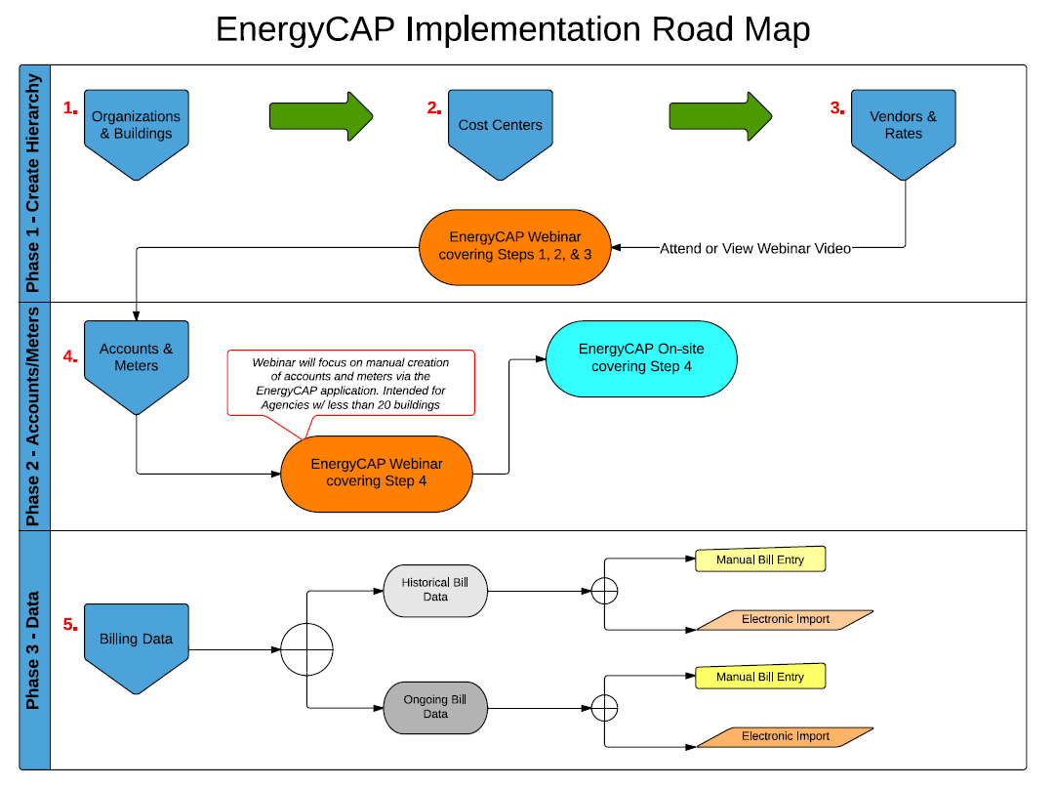
A comprehensive explanation of implementation can be found at the 20x2020 EnergyCAP Implementation page here: https://www.ok.gov/20x2020/Implement.html

This site will give you a detailed step by step process to follow including “How to” documents, short videos, user tips and webinar trainings. If you have any questions please don’t hesitate to contact the 20x2020 team at 20x2020.ok.gov.

