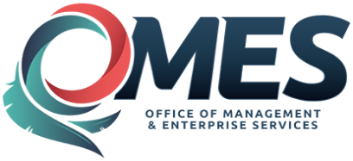 |  | Notice of Statewide Contract Award

Official signed contract documents are on file with OMES-Central Purchasing.
Contract Title: | Pasta - State Use Vendors
Statewide Contract # : |  | SW |  |  |  |  | 97
Contract Issuance Date: |  | 5/10/2010
Total Number of Vendors: |  | 1 |  |  |  |  |  |  |  |  |  |  |  | (For details see: Vendor Information Sheet)
Contract Period: |  | Continuous Contract |  |  |  |  |  |  |  |  |  |  |  |  |  | through |  |  | Does not expire
Agreement Period: |  | Continuous Contract |  |  |  |  |  |  |  |  |  |  |  |  |  | through |  |  |  | Does not expire
Authorized Users: |  | All State Departments, Boards, Commissions, Agencies and Institutions,  in addition to Counties, School Districts and Municipalities which may  avail themselves of this contract.
Contract Priority: |  | THIS CONTRACT IS MANDATORY This contract is awarded according to the  State Use Statute, Title 74, Chapter 48, Sections 3001-3010 et. seq.. This contract  must be used for the purchases of above products.
Type of Contract: |  | This is a firm fixed price contract for the indefinite delivery of supplies specified.
OMES-CP Contact: |  | Daron Hoggatt |  |  |  |  |  |  |  |  |  |  |  |  |  |  | Title: |  |  |  |  | State Use Administrator
Phone: |  | 1 |  | - |  | 405 |  |  | - |  | 521 |  | - |  | 4474 |  |  | Email: |  |  |  |  | daron.hoggatt@omes.ok.gov

