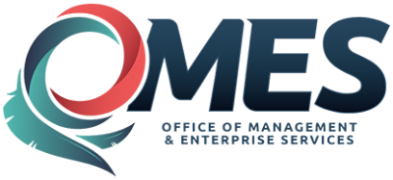 | State of Oklahoma | Statewide Contract  Addendum

This addendum is added to and is to be considered part of the subject contract.

Statewide Contract #: | SW1053M
PeopleSoft Contract ID: | 4372
Contract Title: | Public Safety Communications Equipment
Contract Issuance Date: | 09/23/2015
Contract Supplier: | Motorola Solutions
Addendum # | 3
Addendum Date: | 06/29/2017
OMES Point of Contact:
Contracting Officer: | Marc Brown
Phone Number: | 405-521-3381
E-mail address: | Marc.brown@omes.ok.gov
Addendum Information:
Addendum #3 issued to renew contract with Motorola
Contract Period: 07/01/2017—06/30/2018
Agreement Period: 09/23/2015—06/30/2020

