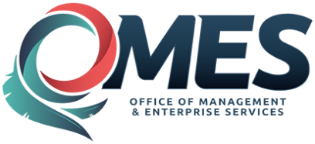 | State of Oklahoma | Statewide Contract  Addendum

This addendum is added to and is to be considered part of the subject contract.

Statewide Contract #: | SW094
PeopleSoft Contract ID:
Contract Title: | Culverts, Steel, Polypropylene
Contract Issuance Date: | 9/15/2015
Contract Supplier:
Addendum # | 2nd Renewal
Addendum Date: | 9/26/2017
OMES Point of Contact:
Contracting Officer: | Joyce Leivas
Phone Number: | 405-521-2479
E-mail address: | Joyce.leivas@omes.ok.gov
Addendum Information:
Both vendors have renewed their contracts for another year until 9/14/2018

