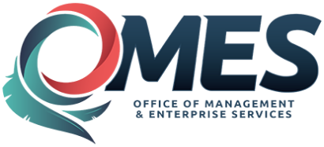 |  | Amendment of Solicitation

Date of Issuance: | 4/18/2019 |  | Solicitation No. |  | 0900000374
Requisition No. |  |  | Amendment No. |  | 1
Hour and date specified for receipt of offers is changed: |  |  | No | Yes, to: |  | CST
Pursuant to OAC 260:115-7-30(d), this document shall serve as official notice of amendment to the solicitation identified above. Such notice is being provided to all suppliers to which the original solicitation was sent.
Suppliers submitting bids or quotations shall acknowledge receipt of this solicitation amendment prior to the hour and date specified in the solicitation as follows:
(1) Sign and return a copy of this amendment with the solicitation response being submitted; or,
(2) If the supplier has already submitted a response, this acknowledgement must be signed and returned prior to the solicitation deadline. All amendment acknowledgements submitted separately shall have the solicitation number and bid opening date printed clearly on the front of the envelope.
ISSUED BY and RETURN TO:
U.S. Postal Delivery:  5005 N Lincoln Blvd  Ste 300  Oklahoma City, OK 73105  or  Personal or Common Carrier Delivery:  5005 N Lincoln Blvd  Ste 300  Oklahoma City, OK 73105 |  | Vanessa Young
 |  | Contracting Officer
 |  | 405 - 202 - 3850
 |  | Phone Number
 |  | Vanessa.young@omes.ok.gov
 |  | E-Mail Address
Description of Amendment:
a. This is to incorporate the following:
The following are questions and answers pertaining to the Disability Actuary Solicitation.

Solicitation Questions

- The provided link to the Disability Handbook (paragraph C.2.2. of the RFP) is broken. Can you provide the information in a different way?

A1. The handbook can be found at the link below.
https://omes.ok.gov/sites/g/files/gmc316/f/HealthChoiceDisabilityHandbook.pdf

- Who were the contractors on the previous contract, and can you provide details on what they charged?

A2. This information is only available through an open records request. The link below explains the Open Records Policy and contains a link to the request form. https://omes.ok.gov/sites/g/files/gmc316/f/OpenRecordsPolicy.pdf

- Would it be possible to see a copy of the previous contractor’s report(s)?

A3. Please see answer A2.

b. All other terms and conditions remain unchanged.
Supplier Company Name (PRINT) |  |  |  | Date
Authorized Representative Name (PRINT) |  | Title |  | Authorized Representative Signature

