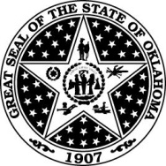 | State of Oklahoma  Office of Management and Enterprise Services | Notice of Statewide Contract Award

Contract Title: | Wireless Services and Equipment – AT&T – WSCA
Statewide Contract #: | ITSW1012A
Contract Issuance Date: | 09/10/2012
Total Number of Vendors: | 1 | (For details see: Vendor Information Sheet)
Contract Period: | 11/01/2016 – 10/31/2017
Agreement Period: | 09/10/2012 – 10/31/2016
Authorized Users: | All State Agencies, Boards, Commissions, Authorities, Counties, Cities, Schools, School Districts, Hospitals, Regents for Higher Education, Colleges, Universities, Municipalities, and Political Subdivisions
Type of Contract: | Discount from List
OMES Contact: | Marc Brown

Email: | Marc.broen@omes.ok.gov
Discount Structure:
- 25% for monthly corporate Responsible Users – (CRUs)
- 50% on Equipment and Accessories
- 15% for Monthly Individual Responsible Users – (IRUs)

