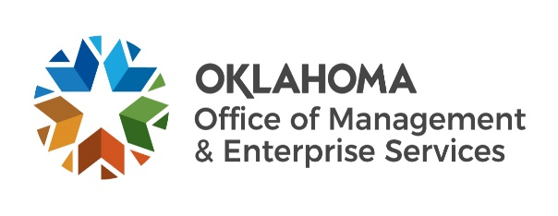 |  | Statewide Contract Summary
Official signed contract documents are on file with OMES Central Purchasing.
Contract title: |  |  | Dental Supplies
Contract Number: |  |  |  |  |  | SW0102HS
Date of Contract issuance: |  |  |  |  |  |  |  |  | 08/20/2025
Contract Period: 08/20/2025 |  |  |  |  |  |  |  |  |  |  |  |  |  |  | through |  |  | 06/30/2026
Agreement period: 07/01/2025 |  |  |  |  |  |  |  |  |  |  |  |  |  | through |  |  |  | 06/30/2028
Type of contract: |  |  |  |  |  |  | Mandatory |  |  |  |  |  |  |  | Non-Mandatory
OMES Central Purchasing contact: |  |  |  |  |  |  |  |  |  |  |  | Asha Parks |  |  |  |  |  |  |  |  | Title: |  | Category Manager
Phone: |  | (405) |  | - | 521 |  |  | - |  | 6674 |  |  |  |  |  | Email: |  |  |  | asha.parks@omes.ok.gov
Supplier name: |  |  |  |  |  | Henry Schein Inc.
Supplier ID: |  | 000012610 |  |  |  |  |  |  |  |  |  |  |  |  | Contract ID #: |  |  |  |  |  | 0-8179
Supplier Point of Contact: |  |  |  |  |  |  |  | Rob Irwin
Supplier address: |  |  |  |  | Address: 135 Duryea Rd. E270
City: |  |  |  |  | Melville |  |  |  |  |  |  | State: NY |  |  |  |  |  |  | Zip Code: 11747
Phone #: |  |  | 661 | 277 |  | 7090 |  |  |  |  |  |  |  |  |  | Email: |  |  |  | Rob.Irwin@HenrySchein.com
Contract Overview:
Purchase of Dental Equipment and Supplies
Authorized Users: All state departments, boards, commissions, agencies, and institutions, in
addition to counties, and municipalities, that provide correctional services, may avail themselves of this contract.
How to order/Procure Services:
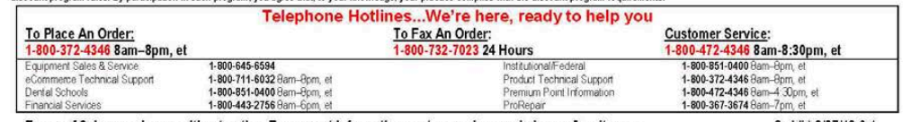
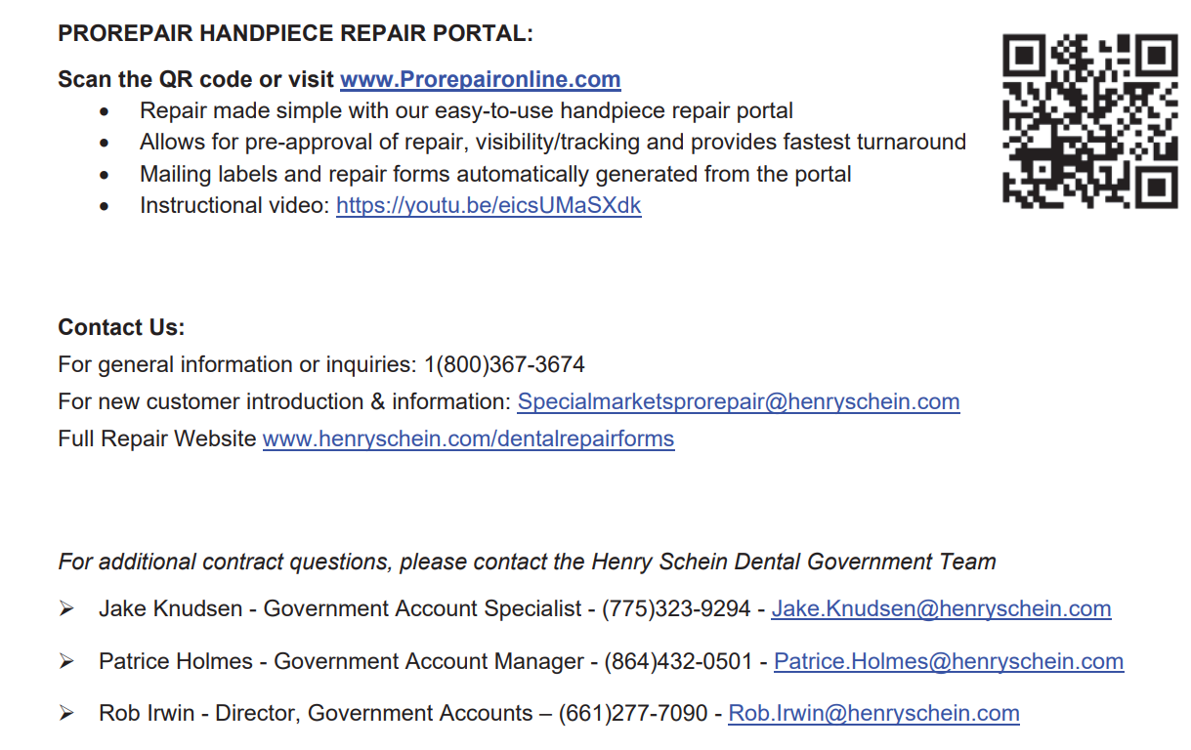
Available Brands:
Dental Equipment | Henry Schein Dental

