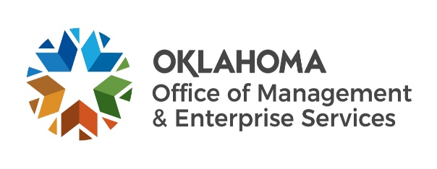 |  | Statewide Contract Summary
Official signed contract documents are on file with OMES Central Purchasing.
Contract title: |  |  | Vehicle Daily Rental (NASPO)
Contract Number: |  |  |  |  |  | SW0771
Date of Contract issuance: |  |  |  |  |  |  |  |  | 08/28/2023
Contract period: 08/28/2023 |  |  |  |  |  |  |  |  |  |  |  |  |  |  | through |  |  | 09/15/2024
Agreement period: 11/26/2019 |  |  |  |  |  |  |  |  |  |  |  |  |  | through |  |  |  | 09/15/2025
Type of contract: |  |  |  |  |  |  | Mandatory |  |  |  |  |  |  |  | Non-Mandatory
OMES Central Purchasing contact: |  |  |  |  |  |  |  |  |  |  |  | Cristy Newton |  |  |  |  |  |  |  | Title: |  | Contracting Officer 1
Phone: |  | (405) |  | - | 521-6721 |  |  |  |  |  |  |  |  |  |  | Email: |  |  |  |  | cristy.newton@omes.ok.gov
Supplier name: |  |  |  |  |  |  |  |  |  | HERTZ CORPORATION
Supplier ID #: |  |  |  |  |  |  | 0000068201 |  |  |  |  |  |  |  |  |  |  |  |  |  |  |  |  |  |  |  |  |  |  |  |  |  |  |  |  |  |  |  |  |  |  | Contract ID #: |  |  |  |  |  |  |  |  |  | 7043
Supplier Point of Contact: |  |  |  |  |  |  |  |  |  |  |  |  |  |  |  |  |  |  |  | Nadika Perera
Supplier address: |  |  |  |  |  |  |  |  |  |  |  | 6605 NW Expressway
City: |  |  |  |  |  |  |  |  |  |  |  | Oklahoma City |  |  |  |  |  |  |  |  |  |  |  |  |  |  |  |  |  | State: |  |  |  |  |  |  |  |  |  |  |  |  |  |  | OK |  |  |  |  |  |  |  |  |  |  |  | Zip Code: |  |  |  |  |  | 73132 |  |  |  |  |  |  |  |  |  |  |  | -
Phone #: |  |  | 1 |  | - |  |  |  | 239 |  |  |  |  |  |  | - |  | 301 |  |  |  |  | - |  | 7635 |  |  |  |  |  |  |  |  |  |  | Email: |  |  |  |  |  |  |  |  |  | Nadika.perera@hertz.com
Supplier name: |  |  |  |  |  |  |  |  |  | Enterprise Holdings Inc.
Supplier ID #: |  |  |  |  |  |  | 330302 |  |  |  |  |  |  |  |  |  |  |  |  |  |  |  |  |  |  |  |  |  |  |  |  |  |  |  |  |  |  |  |  |  |  | Contract ID #: |  |  |  |  |  |  |  |  |  |  |  |  | 5671
Supplier Point of Contact: |  |  |  |  |  |  |  |  |  |  |  |  |  |  |  |  |  |  |  |  |  | Harlan Weaver
Supplier address: |  |  |  |  |  |  |  |  |  |  |  |  |  | ENTERPRISE HOLDINGS INC EAN SERVICES LLC 14002 E 21ST ST STE 1500 TULSA OK 74134-1424 USA
Phone #: |  |  |  | 1 |  | - |  |  |  |  | 405 |  |  |  |  |  | - |  | 254 |  |  |  |  |  |  | 9733, |  |  |  |  |  |  |  |  |  |  |  | Email: |  |  |  |  |  |  |  |  |  |  |  |  | harlan.b.weaver@em.com
Contract Overview:
Vehicle Rentals
Authorized Users: All state departments, boards, commissions, agencies, and institutions, in
Addition to counties, school districts and municipalities which may avail themselves of this
contract.
How to order:
Contact Supplier: Nadika Perera to get a discount code for your agency. See contact details above.
Available Brands:
Hertz Rental Cars, Enterprise Car Rentals
Available Products and Services:
Rental Cars

