ATTACHMENT A

This Solicitation is a Contract Document and is a request for proposal in connection with the Contract awarded by the Office of Management and Enterprise Services as more particularly described below. Any defined term used herein but not defined herein shall have the meaning ascribed in the General Terms or other Contract Document.

PURPOSE

The Contract is awarded on behalf of the Oklahoma Water Resources Board for engineering firms who are interested in providing general engineering services related to the State of Oklahoma’s comprehensive state flood plan according to the Oklahoma Statutes Section 1623 of Title 82.

The state flood plan shall include:

An evaluation of the condition and adequacy of flood control infrastructure on a watershed basis;
2. A state-wide list of ongoing and proposed flood control and mitigation projects and strategies necessary to protect against the loss of life and property from flooding and a discussion of how those projects and strategies might further water development where applicable;
3. An analysis of completed ongoing and proposed flood control projects included in previous state flood plans including which projects received funding;
4. An analysis of development in special flood hazard areas, as defined by the Federal Emergency Management Agency; and
5. Legislative recommendations the Board considers necessary to facilitate flood control planning and project construction.

Actual Scope of Engineering Services would be agreed upon through a written contract and depend on the activities that would be funded by various grants including but not limited to FEMA Hazard Mitigation Grant Program (HMGP), FEMA Building Resilient Infrastructure and Communities (BRIC), and US HUD Community Development Block Grant – Disaster Recovery (CDBG-DR).
The project shall be divided into two (2) deliverables based on the watershed area as shown

REGION | COMPLETION DATE
Eufaula  Grand  Lower Arkansas  Middle Arkansas  Upper Arkansas | January 31, 2023
Beaver-Cache  Blue-Boggy  Central  Lower Washita  Panhandle  Southeast  Southwest  West Central | December 31, 2023

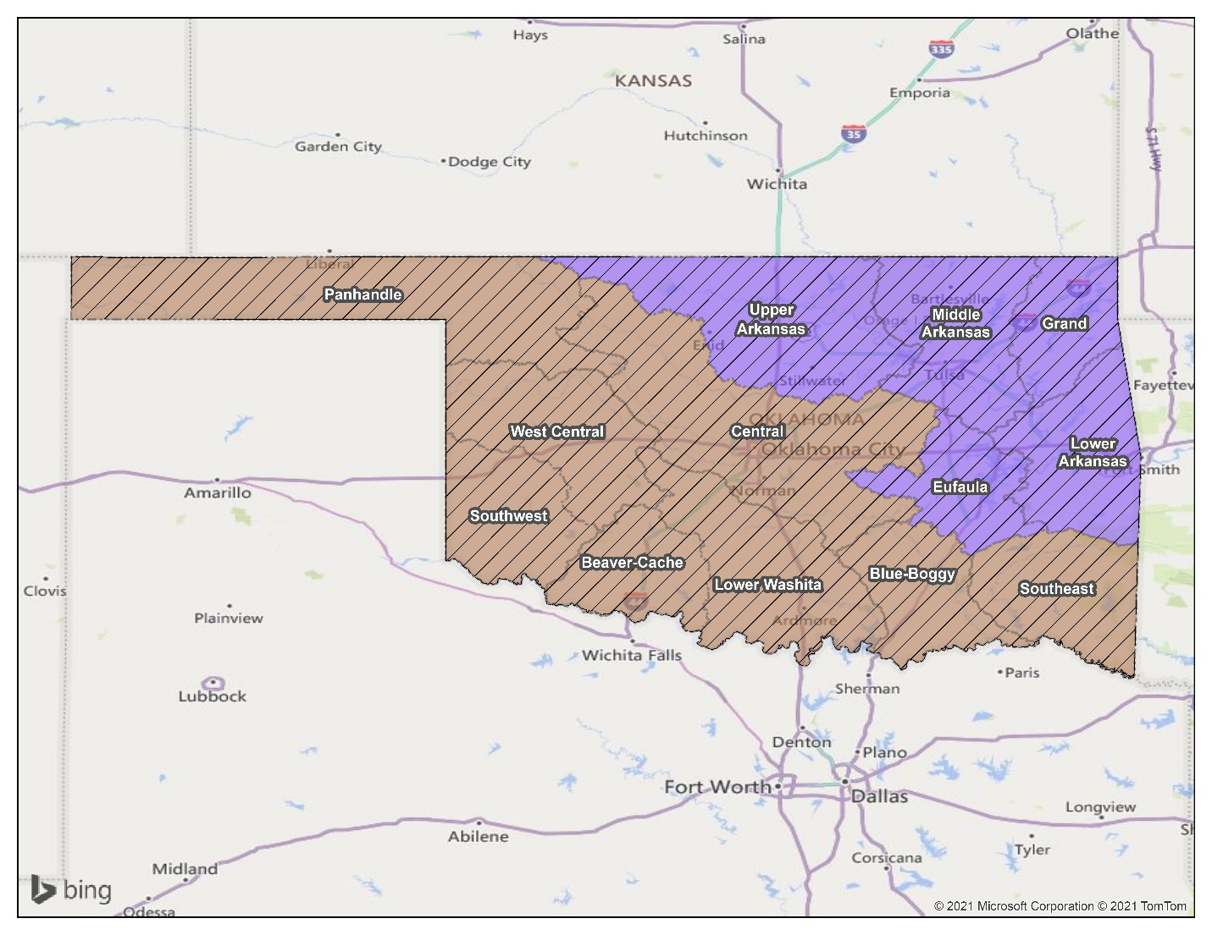

FUNDING
It should be noted that no existing funding is available to compensate for the outlined services. It is anticipated that the funds to pay for these services will be provided by FEMA and US HUD under its HMGP, BRIC and CDBG-DR programs in the amount not to exceed $1,364,868,00. Future funding will be dependent upon a number of factors including but not limited to budget approvals and funding availability.

1. Contract Term and Renewal Options
The contract term, which begins on the effective date of the Contract, is one year and there are [THREE] one-year options to renew the Contract.

