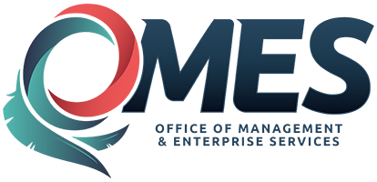 |  | Statewide Contract  Addendum

This addendum is added to and is to be considered part of the subject contract.

Contract Issuance Date: | 05-23-2014
Statewide Contract #: | SW 210
Contract Title: | Oklahoma Travel Initiative
Addendum Date: | 05-17-2016
Addendum #: | 2

This addendum provides written notice that both parties have agreed to the second (2) optional renewal period for a one year period.

Revised Contract Period:

May 23, 2016 through May 22, 2017

Oklahoma Contract Identification Number: 0-3741
Oklahoma Vendor Identification Number: 0000376453
FCM Contact: Scott Reddie ] Scott.Reddie@us.fcm.travel

Please direct any questions to:

Lisa Bradley, CPO
SW Initiatives Contract Officer
405-522-4480
Lisa.bradley@omes.ok.gov

