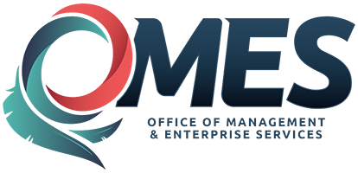 | Mandatory Statewide Contract Request for Exception
Unless otherwise prohibited by law, whenever a state agency determines it is in the best interest of the state to acquire a product or service from a source other than a mandatory statewide contract, the agency shall submit this form to Central Purchasing to request an exception. If the initial exception request is denied, the state agency may appeal the decision by resubmitting the request to the State Purchasing Director for consideration. A state agency may not complete the acquisition without prior written approval of the exception request by a Contracting Officer or the State Purchasing Director, which shall be maintained in the acquisition file.
Agency Name: |  |  |  |  |  | Agency Number: |  |  |  |  |  |  | Request Date:
1. | Statewide Contract # |  |  |  |  |  | PeopleSoft Contract ID#
2. A detailed explanation is required in the box below. Attach all additional supporting documentation including savings to agency, quotes, etc. with
this request.

3. | Required delivery time for the acquisition: |  |  |  |  |  |  | 4. | Expected dollar amount of the acquisition:
5. Agency representative requesting exception: |  |  |  |  |  |  |  |  |  |  | Email:

FOR OFFICE OF MANAGEMENT AND ENTERPRISE SERVICES USE ONLY

Approved ☐ Denied ☐

Recommendation/Comment:

Contracting Officer: Date:

In response to the Agency’s appeal of the exception denial documented here, I have reviewed said request for an exception from use of the statewide contract and in accordance with OAC 260:115-7-3 hereby determine the exception:

Approved ☐ Denied ☐ - Reason for Denial:

Recommendation/Comment:

State Purchasing Director Signature Date

