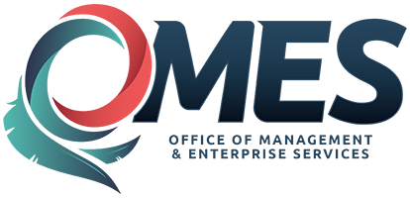 |  |  | Authority Limit Waiver Request
Agency Name: |  |  |  |  |  |  |  | Agency Number:
Agency Requisition #: |  |  |  |  |  |  |  | Purchase Order #:
Vendor Name: |  |  |  |  |  |  |  | Vendor FEI/SSN:
Original Amount ($): |  |  |  |  |  |  |  | Modified Amount ($):
Type or Nature of service or product provided:
Department or division that requested service or product:
Explanation of the inadvertent administrative error or unforeseeable circumstance which caused the acquisition to exceed the purchasing authority limit in 74 O.S. § 85.7.A.2.b. :
I hereby request a waiver of the agency's authority limit not to exceed a 10% increase of the acquisition amount.
Signature |  |  |  |  |  | Date
Printed Name |  |  |  |  |  | Printed Title
( ) -
Phone Number
Submit this form to the State Purchasing Director for review:
 |  |  | CP.Feedback@omes.ok.gov
(FOR STATE PURCHASING DIRECTOR USE ONLY)
 | The waiver request has been: □ Approved; □ Denied
 | State Purchasing Director |  |  |  |  |  |  |  | Date
 | Comments:

