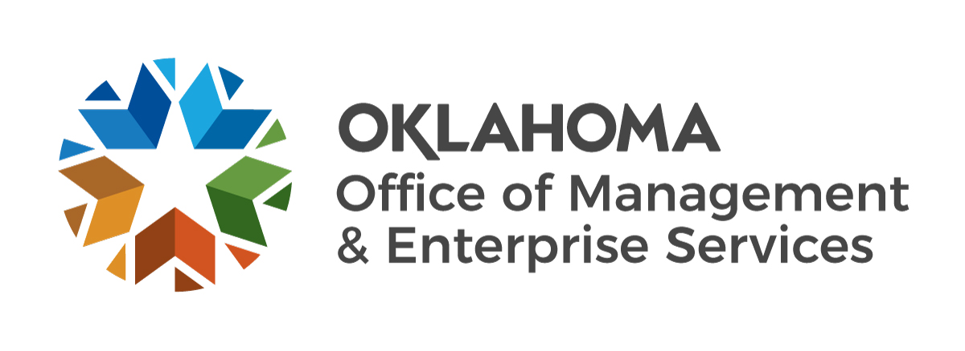 | Professional Services  Requisitioning Guide

This guide has been prepared to assist agencies in the preparation of contracts for Professional Services exempt from the competitive bidding process. See Title 18 O.S. § 803 for those professions exempt from competitive bidding. See Title 74 O.S. § 85.4 & §85.41 for requirements pertaining to professional services.

- The following is representative (not all inclusive) of criteria/requirements of a contract document:
  - Parties to the contract stated as one of the following:
    - When contracting with an individual, name of licensed contractor
    - When contracting with a company for the services of an individual(s) name of company, including name(s) of licensed employee(s) conducting contract work
  - Contract Requirements/Scope
  - Compensation rate, e.g.: per hour rate, rate for various assignments, etc.
  - Method of payment
  - Performance measures
  - Contract administrator/agency contact
  - Terms and Conditions, i.e.:
    - Contract Period
    - Renewal Clause (state option(s), if considering multiple years)
    - Termination Clause
    - Oral Agreements Clause
    - Audit/Retention of Records Clause
    - Insurance Clause (if applicable)
    - Equal Employment Opportunity Clause (if applicable)
    - Workers Compensation Clause (if applicable)
    - Liability Clause (if applicable) Default Clause
    - Inspection of Services
    - Any additional terms required by the agency
  - Signature of both parties
  - At least one original of the contract (when submitting to Central Purchasing), and any additional originals required by your agency

- Documentation required for agency file:
  - Executed original copy of contract containing the above requirements
  - Contract Non-Collusion Certification: https://www.ok.gov/dcs/searchdocs/app/manage_documents.php?id=1588
  - Copy of license of individual(s) performing service
  - Attorney General's approval when contracting with an attorney. See Title 74 O.S. § 20i
  - Work Plan
  - Professional or nonprofessional service statutory language included pursuant to Title 74 O.S. § 85.4

- If Central Purchasing is required to process the acquisition, the following is to be submitted to Central Purchasing:
  - Executed original of contract containing the above requirements
  - Requisition to Central Purchasing
  - Professional or nonprofessional service statutory language included pursuant to Title 74 O.S. § 85.4
  - Contract Non-Collusion Certification: https://www.ok.gov/dcs/searchdocs/app/manage_documents.php?id=1588
  - Attorney General's approval when contracting with an attorney
  - Work Plan

