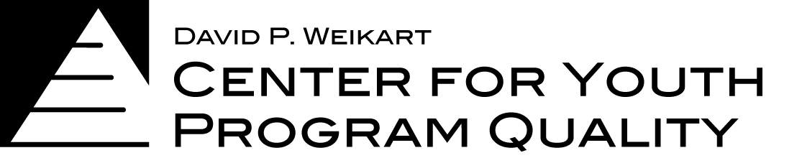
OSDE New Grantee - Box Set Cover Sheet

Thank you for being part of the Oklahoma State Department of Education’s
21st CCLC Continuous Improvement Process!
This box set includes everything you’ll need to conduct a program self assessment using the Program Quality Assessment (PQA) and fulfill all USDE evaluation requirements. Our goal is to integrate these various data sources to provide you with meaningful information through Leading Indicators that can support you in continuous quality improvement.

This Box Set Includes:
- Box Set Cover Sheet and Timeline
- 2 Copies of PQA Form A (School-Age or Youth PQA, depending on what age groups your programs serve)
- 1 PQA Handbook (School-age or Youth)
- 1 user login to the Scores Reporter Online Database to enter self assessment data (see page 2 for more information)
- 1 YPQA Pyramid poster
- 1 Set of PQA playing cards (School-age or Youth)
- 1 Set of Youth Work Methods handbooks
- 2 Online accounts to access Youth Work Methods online courses
- Technical Assistance support on Program Quality Assessment, Scores Reporter/Online Courses and Evaluation services

Weikart Center Contact Information:
Program Quality Assessment (Self-Assessment and Program Improvement Supports)
- Angelina Garner
- 734-714-2523
- Angelina@cypq.org

Evaluation (PPICS Data, Survey Collection and Leading Indicator Report Support)
- Anna Gersh
- 734-714-2527
- Anna@cypq.org

Online Scores Reporter and Youth Work Methods Account Support
- Paul LaMacchia
- 734-714-2508
- plamacchia@cypq.org

Program Evaluation
(Surveys, USDE Data)
Program Quality Improvement
(YPQA, SAPQA)

Data Driven
Continuous
Improvement
More Meaningful
Feedback
(Leading Indicators)

Program Quality Assessment Information

Program Quality Assessment - As you prepare to facilitate your Program Self – Assessment and create your Program Improvement Plans you may have questions about the process such as materials and staffing needed to implement the process. If any questions arise for you about this process, please contact Angelina Garner at angelina@cypq.org or 734-714-2523.

Online Scores Reporter and Youth Work Methods accounts - Online Scores Reporter accounts allow you to enter your PQA self-assessment data and Program Improvement Plan online. You will learn how to use the account at the webinars listed below. Your online Scores Reporter account information will be emailed to you after your YPQI Resource Box Set has been purchased, processed and mailed to you. If you do not receive this information within 2 weeks after your box set has been delivered, please contact Paul LaMacchia at plamacchia@cypq.org or 734-714-2508.

External Assessment - Grantees that are in the second and third year of their grant will be engaging with a deeper intervention that involves external assessment. A trained, reliable external assessor will come to your sites to observe one - two program offerings. Payment to the external assessors is made through your grant funds. You will be contacted by your external assessor to schedule a visit. The fee for external assessment is $500.00 per site. Mileage for external assessor travel to the site is included in this fee. This fee will cover with one - two observations per site, which includes 45-60 minutes of observation each and then scoring. The State Department of Education, 21st CCLC office will facilitate the process of connecting sites and assessors, support scheduling, monitor the quality of assessments and manage the overall experience.

2015-2016 Quality Improvement Timeline

Date/Time |  | Activities
September 28-29, 2015 |  | OSDE Kickoff Event (YPQI, Leading Indicator and PPICS overview)
October 8-9, 2015 |  | Live Youth PQA Basics (1) and PQA Plus training (1) (site lead plus other staff as needed) – facilitated by Weikart Center Consultant. Sites will order their materials necessary to conduct the self-assessments and will receive them by mail.
October 12 – December 4, 2015 |  | Site teams conduct program self-assessment and work with External Assessor to schedule visit to appropriate programming
October 21, 2015 |  | NEW Score Reporter 3.0 overview webinar  October 21 - Webinar / 12:00 -1:00 pm (CST)
November 4, 2015 |  | Self-Assessment Check-in & Scores Reporter Webinar  November 4 - Webinar / 3:00 -4:00 pm (CST)
November 7, 2015 |  | Youth Work Methods training (Location: TBD)
December 4, 2015 |  | DUE DATE: PQA Self-Assessment Data and External Assessment Data due in Scores Reporter
January 28-29, 2016 |  | Live Advanced Planning With Data Workshops (site teams) – facilitated by Weikart Center trainers and OK TACSS Coaches (2 workshops)
January 2016* |  | USDOE Federal Grantee data collection process webinar #1
January 2016* |  | DUE DATE – USDOE Federal Grantee Profile Due
February 10, 2016 |  | Improvement Planning Webinar  February 10 - Webinar / 3:00 -4:00 pm (CST)
February 13, 2016 |  | Youth Work Methods training (Location: TBD)
February 19, 2016 |  | DUE DATE- Improvement Plans due in Scores Reporter
February – April 2016 |  | Evaluation Surveys - (Grantee Directors, Site Coordinators, Afterschool teacher/Youth Worker, Youth and Parent Surveys administered)
March 4, 2016 |  | Quality Coaching training
April 2016* |  | USDOE Federal data collection opens for APR opens
April 2, 2016 |  | Youth Work Methods training – April 2016 (Location: TBD)
April 26 – May 6, 2016 |  | YPQI surveys: Quality Assessment and Improvement Surveys (Grantee Director and Afterschool Staff)
May 2016* | USDOE Federal Grantee data collection process webinar #2
May 2016* | DUE DATE - USDOE Federal Grantee Data Collection - Deadline #1 – (Operations,  partners, and feeder schools data due)
June 30, 2016* | DUE DATE – USDOE Federal Grantee Data Collection – Deadline #2 – Data  Spreadsheet (Activities, Attendance, Staff and State Assessment data due)
August 2016* | DUE DATE - USDOE Federal Grantee Data Collection - Deadline #3 – (Resubmission of  the data management spreadsheet with complete state assessment information)
Winter 2016 | State Evaluation Reports

* The exact dates and times for this support will be determined based on the release date of the new USDE Data Collection System.

