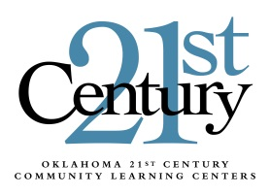

Carryover Procedures, Year-End Claims, and Closeout
2014 - 2015

Please read the following carefully and share with your financial office.

The carryover procedures for the 21st Century Community Learning Center (21st CCLC) grants are as follows:

- All grantees in years 1 – 4 of the grant cycle may carryover up to 10% of the base allocation for the current year without prior approval from the 21st CCLC program office at the Oklahoma State Department of Education (OSDE). The base allocation amount is the current year allocation without any previous year carryover.

- Carryover exceeding 10% of the base allocation will not be allowed.

- Grantees in year 5 of the grant cycle will not be allowed carryover funding.

Please remember that expenditures must be preapproved by the 21st CCLC office prior to purchasing if: 1) a single item exceeds $1,000; 2) the total purchase exceeds $2,500; or 3) the purchase is outside of your original grant application.

Important dates to remember include:
- June 1, 2015 – Last day to submit a claim in payable form to receive payment by the end of the fiscal year and record it as FY2015 revenue.
- August 3, 2015 – Final day for all 2014 – 2015 claims to be received at OSDE.
- August 31, 2015 – Closeout in the Grants Management System must be complete.

21st CCLC funding is awarded based on a competitive grant competition. In order to process allocations for the new fiscal year ALL grantees must first complete closeout. If you are unsure of your current base allocation or have further questions please feel free to contact our office.

Sonia Johnson, Executive Director
21st Century Community Learning Centers
Oklahoma State Department of Education
2500 N. Lincoln Blvd., Suite 414
Oklahoma City, Oklahoma 73115
(405)522-6225
Sonia.Johnson@sde.ok.gov

